**DEVELOPMENT OF AMMONIA LEVEL DETECTOR**

**FOR IDENTIFYING SELECTED MEAT**

**A Research Project**

Presented to the Faculty of the

**Undergraduate Program**

College of Industrial Technology

Technological University of the Philippines at Cavite

Carlos Q. Trinidad Ave., Salawag,

Dasmariñas City, Cavite

by

**ELLA MAE C. CORTES**

**BRECHY M. ROSALES**

**RHEIGNE MARRIE D. SANDAGAN**

**HANNAH MERL JOSEPHINE M. TORRES**

**MARIE FLORENCE D. VISPERAS**

In Partial Fulfillment of the Requirements for the Degree

**Bachelor of Technology Major in Computer**

**Engineering and Technology**

January 2023

**ACKNOWLEDGEMENT**

This study was made possible by the assistance of significant individuals who advised and supported the Researchers during the execution of this study. Their heartfelt thanks go to the following people who aided them in broadening their viewpoint throughout this study:

Their parents, who constantly supported them financially, morally, and spiritually from the start of the study to its completion. Their morale and spirit were enhanced as a result of the encouragement. They would also want to thank them for their unending patience and unwavering determination.

Their Subject professor, Mr. Neil Jayson Narciso who, through his knowledge and guidance, greatly aided them in developing their thoughts and writing abilities;

Their Research Adviser, Mr. John Paulo M. Diaz, for imparting his knowledge and experience with them and supervising their work on this thesis;

Their Panelists, Mr. Arnold De Vega, Ms. Beverly De Vega, Ms. Juliet Escalona and Mr. Jay Victor Gumboc, for their support, informative remarks, and recommendations for making this research paper a success;

Their Friends, who were there to keep them motivated and focused on making it through, as well as cheering them up whenever they were worn out;

And, most importantly, to the Almighty God for the wisdom and strength He has given them during this research paper.

The Researchers

**ABSTRACT**

To address the problem of the meat spoilage that can escalate to food poisoning if consumed, a portable electronic ammonia sensor that can detect meat spoilage has been developed. Numerous potentially dangerous living circumstances are accompanied by distinctive odors that can serve as an early warning system. In this work, we dive deep into the topic of ammonia gas monitoring, two different sensor arrays (MQ-137 & MQ-135) are used for this device, with a focus on detecting meat spoilage. The device is tested with three different meats including pork, chicken, and beef. It indicates 3 levels of meat freshness (fresh, not so fresh, and spoiled). At the start of the measurement period, there was no difficulty differentiating between any meat. But as spoilage progressed, so did the odor profiles of the meat. Preliminary results from this study indicate that meat spoilage detector technology may be a good fit for integration into the smart home. However, for widespread acceptance to occur, future development must continue to address current limitations like instability, user intervention, and high cost.

**TABLE OF CONTENTS**

**PRELIMINARIES Page**

Title Page i

Approval Sheet

Acknowledgement

Abstract

Table of Contents ii

List of Tables iii

List of Figures iv

**Chapter 1 - INTRODUCTION**

Background of the Study 1

Objectives of the Study 4

Scope and Limitations of the Study 5

Significance of the Study 6

**Chapter 2 – CONCEPTUAL FRAMEWORK**

Review of Related Literature and Studies 7

Conceptual Model of the Study 37

Operational Definition of Terms 39

**Chapter 3 – METHODOLOGY**

Project Design 42

Project Development 47

Operation and Testing Procedure 52

Evaluation Procedure 55

Scale Range and its Qualitative Interpretation

**Chapter 4 - RESULTS AND DISCUSSION**

Project Description

Project Structure

Project Test Results

Project Capabilities and Limitations

**Chapter 5 - SUMMARY OF FINDINGS, CONCLUSION AND RECOMMENDATIONS**

Summary of Findings

Conclusions

Recommendations

**REFERENCES**

**APPENDICES**

**RESEARCHERS PROFILE**

**LIST OF TABLES**

| **TABLE** | **TITLE** | **PAGE** |
| --- | --- | --- |
| 1 | NH3 Meat Level of Freshness | 24 |
| 2 | Testing Results for Adding and Deleting Scanned Data | 79 |
| 3 | Testing Results for Editing of Scanned data information | 80 |
| 4 | Testing Results for downloading records as CSV file | 81 |
| 5 | Testing Results for Clearing all records | 82 |
| 6 | Testing Results for Pairing Device to Mobile Application Using USB-C Cable | 83 |
| 7 | Testing Results for Standalone Device | 84 |
| 8 | Testing Results for Connected Device and Mobile Application | 85 |
| 9 | Testing Results for Ammonia Test Drop and Device for Cooked Meat Table | 86 |
| 10 | Testing Results for Ammonia Test Drop and Device for Raw Meat Table | 87 |
| 11 | Testing Results for Scanned Sample Time and Date | 88 |

**LIST OF FIGURES**

| **FIGURE** | **TITLE** | **PAGE** |
| --- | --- | --- |
| 1 | Consumption per capita in kilograms | 15 |
| 2 | Fresh and stale state of chicken | 17 |
| 3 | Fresh Raw beef | 18 |
| 4 | Spoiled Raw Beef | 18 |
| 5 | Fresh Chicken Appearance | 19 |
| 6 | Spoiled Chicken Appearance | 19 |
| 7 | Hue of fresh pork | 20 |
| 8 | Hue of spoiled pork | 20 |
| 9 | Pork Quality Standard Appearance | 21 |
| 10 | Level of Freshness Chart | 22 |
| 11 | Refrigerator/Freezer Food Storage Chart | 29 |
| 12 | Design Thinking Model Diagram | 54 |
| 13 | . Isometric View of Food Spoilage Detector | 60 |
| 14 | Main Screen | 60 |
| 15 | Device for connecting page | 61 |
| 16 | Connected device page | 61 |
| 17 | Brief Instruction Page | 61 |
| 18 | Output Application Display | 62 |
| 19 | History Page | 63 |
| 20 | Edit page | 63 |
| 21 | Block Diagram of the Food Spoilage Detector | 64 |
| 22 | Exploded View of Food Spoilage Device | 65 |
| 23 | Arduino Nano Microcontroller Board | 66 |
| 24 | MQ-135 Gas sensor for Air Quality | 66 |
| 25 | MQ-137 Ammonia Detection Sensor | 67 |
| 26 | Lithium Ion Polymer 3.7V Battery | 67 |
| 27 | TP4056 Lithium Battery Charger Module - Type C | 68 |
| 28 | DIP Adapter Female Connector - Type C Socket | 68 |
| 29 | SPST Miniature rocker switch | 69 |
| 30 | Mini Buzzer With Dupont Connector | 69 |
| 31 | Tactile Push Button | 70 |
| 32 | Light Emitting Diode | 70 |
| 33 | RGB | 71 |
| 34 | Device Data Flow Diagram | 71 |
| 35 | Mobile Application Data Flow Diagram | 72 |
| 36 | Prototype of the Meat Spoilage Detector Device | 79 |
| 37 | Unfinished Meat Spoilage Detector Device | 80 |
| 38 | Meat Spoilage Detector Device Components | 81 |
| 39 | Starting Page | 82 |
| 40 | Connecting Device Page | 82 |
| 41 | Mobile Phone Devices Available | 83 |
| 42 | Brief Instruction | 83 |
| 43 | Fresh Status | 84 |
| 44 | Not so Fresh Status | 84 |
| 45 | Spoiled Status | 84 |
| 46 | History Page | 85 |
| 47 | Edit Page | 85 |



**Chapter 1**

**INTRODUCTION**

**Background of the Study**

Food is one of the fundamental human necessities needed in everyday life. It contains nutrients that the human body needs. Considering this as one of humankind's necessities gives an opportunity for entrepreneurs and business people to open a restaurant. Eating at a restaurant is handy for people, especially employees, students, and people who do not have time to cook. Many restaurants provide various continental cuisines such as Asian, European, and Western. A popular example of this are Korean restaurants that mostly offer a traditional way of serving food in a form of barbecuing inside. (SBS Food, 2008).

It is crucial to notice food abnormalities in order to prevent unfavorable development, such as food spoilage, a natural process that results in undesirable alterations in sensory qualities in the form of texture, odor, appearance, and flavor. This circumstance not only results in monetary losses but also a dearth of food sources that can be consumed. Based on Gram et al. (2002), and Remenant et al. (2015), Even with modern preservation techniques, an inordinate amount of food is wasted owing to spoilage. The United Nations Food and Agriculture Organization found in a study conducted in 2016 that annually, the world's food supply is lost or squandered. However, the meat business has made significant efforts to reduce food waste, poisoning occurrences, and spoilage. Due to massive growth of population, the economical significance of these technical advancements has increased as the life quality and nutritional requirements of society have risen. (Kristensen, Stier, Würtz, & Hinrichsen, 2014). Food hygiene and safety are critical concerns in order to reduce food waste. Unquestionably, ready-to-eat meat products have become a staple of modern meals. This current food culture requires rigorous food quality and safety standards for the product's entire commercial life, with additional stringent criteria for foreign trade. Temperature, humidity, and darkness must be controlled to prevent food from decaying.

According to Gram et al. (2002), 25% of all food produced globally is wasted due to microbial deterioration despite refrigeration, synthetic preservatives, and improved techniques, resulting in the prevalent source of changes in food quality. As microbial survival takes diverse paths based on many circumstances that occur, visible growth, texture alterations. or changes in odor and flavor are some of the observable impacts (Nychas et al., 2008). Based on a study conducted by Doulgeraki et al. in 2012, meat is one of the most perishable foods compared to a variety since its nutritional mix, high water content, and moderate pH make it perfect for growing a wide range of microorganisms.

This study will only include three (3) varieties of meat: pork, beef, and chicken. Since the aforementioned meats are the most commonly purchased at the market and are generally cooked and served in restaurants, specifically restaurants that offer samgyeopsal. As a result, various forms of meat in the study are not mentioned. The most important source of high-quality dietary protein is meat. The affection for meat items by nearby buyers in the Philippines saw an ascent in meat utilization, most explicitly for pork meat. By 2021, it was anticipated that pork would be the most consumed sort of meat in the Philippines at around 15 kilograms for every individual per annum ( Statista Research Department, 2022). As the demand of supply in meat increases, food safety, particularly meat safety is important and it should be everyone's responsibility. We need to be part of maintaining food safety in our own locality and the entire country to ensure the health & wellness of each & everyone, especially of the consumers.

With technology’s progression, people's reliance on smartphones, and rising demands for simple and quick solutions to their day-to-day duties, it becomes critical to have technical control over industrial and residential applications using IoT. As a result, quality monitoring equipment at stores or markets is beneficial. These food quality monitoring systems keep an eye on the factors that cause or hasten food degradation.

**Objectives of the Study**

**General Objectives**

To create a cost-effective food spoilage device to improve the process of determining spoiled meat for selected meat restaurants in Bacoor, Cavite. To ensure convenience for restaurant workers and similar patrons, and to lessen food wastage that can lead to loss of revenue and occurrence of food poisoning.

**Specific Objectives**

1. To design and develop a device that can:

1.1 Identify the level of freshness of raw and cooked beef, pork, and chicken meat.

1.2 Determine the total number of meat quality scanned – fresh , not so fresh, and spoiled.

1.3 Show the records of meat scan date/time and purchase information.

1. To achieve at least 90% functionality through the communication of sensors in the device and data from samples.
2. To evaluate the food spoilage detector using the criteria for a prototype in terms of functionality, accuracy, and reliability, to achieve a rating of at least 90%. The evaluation form for the prototype is based on the Likert Scale.

**Scope and Limitations of the Study**

This study focuses on detecting ammonia levels to identify meat level of freshness. The data collection will be conducted at selected diner, Samgyupsal type restaurants in Bacoor, Cavite which will represent the population. This study will feature only these three (3) types of meats namely pork, beef, and chicken. For the reason that the said types of meat are the most served meat dish in the target area of the population of the said paper. Processed meat of the selected three types of meats are not included, for the reason that preservatives are added to the processed meat. Thus, the prototype will only focus on beef, pork, and chicken meat; other types of meat that are not mentioned by the researchers are not included in the said scope of the study.

The prototype is intended to detect if the selected cooked and raw meat are spoiled, by utilizing two sensors and sending its data to the mobile application. (1) MQ-135 sensor; sensor module used to detect Ammonia & other toxic gasses; and (2) M-137 sensor; sensor module mainly used to detect Ammonia (NH3) gas. Thus, using these sensors, the prototype will only get the Ammonia Content of the test subject whether cooked or raw, to perform and identify the freshness status of the meat that will be displayed in an android mobile application. To perform the display function, the mobile application is built using the Android Studio interface. The prototype mobile applications are only available in mobile phones whose operating system is Android and has a type-c port. Thus, other mobile operating systems will not be used at the said prototype. This prototype can diminish food waste coming from other food establishments, especially in meat restaurants. It also aids in protecting people from food poisoning caused by eating spoiled food. The prototype will then use the local area and USB C to C data connection network for the data transmission for data , thus other backend data transmission is not supported in the said study. The research would be done by performing countless trials of the selected test subject, and utilization of questionnaires and interviews with the selected population area, in the form of a survey and all the collected data will stand as a reference and basis of the study.

**Significance of the Study**

The purpose of this study's findings is to provide significant information and knowledge to the researcher, benefactor, and business area in samgyeopsal restaurants around Bacoor, Cavite. The proposed Development of Ammonia Level Detector for Identifying Selected Meat will be beneficial for the following:

**Samgyeopsal Diners.** The samgyeopsal restaurants can benefit a lot from this study as it helps them in determining if any raw meat (pork, beef, and chicken) in their refrigerator has gone bad with the help of a meat spoilage detection device and a mobile application to display results. It was also developed to help samgyeopsal restaurants avoid food poisoning incidents in their business by alerting them to the freshness of their raw meat and their cooked meat before they serve it.

**Consumers.** It allows consumers who are concerned about the health of themselves and their loved ones to swiftly assess the freshness of the meat that they are going to eat or serve to their family or guests through a meat spoilage detection device connected to a mobile application via a wired connection.

**Researchers.** The researchers have improved their writing, analytical, and thesis-writing abilities, which will aid in the improvement of our society as a whole.

**Innovators.** The findings from this study will help future academics who want to replicate this study or conduct their own research into detecting meat deterioration.

**Chapter 2**

**CONCEPTUAL FRAMEWORK**

This chapter introduced the journals, research and papers that supported the research framework and conceptualization These references underpinned the foundation and process of the study. It also provided the information needed to select the materials and components used in the prototype development. This ultimately included a description of the conceptual model used in the study and a definition of the terms’ operation and function.

**Review of Related Literature and Studies**

**Meat Level of Freshness**

The most popular meats in the country are pork and chicken. While Filipinos ate about 13.74 kilograms of chicken and turkey each in 2020, they consumed about 14.9 kilograms of hog. Consumer food security and safety are the country’s key priorities, and with rising demand and reliance on global supply, there is an urgent need to create and promote globally approved science-based standards for meat product sustainability, predictability, and safety (Statista Research Department, 2022). 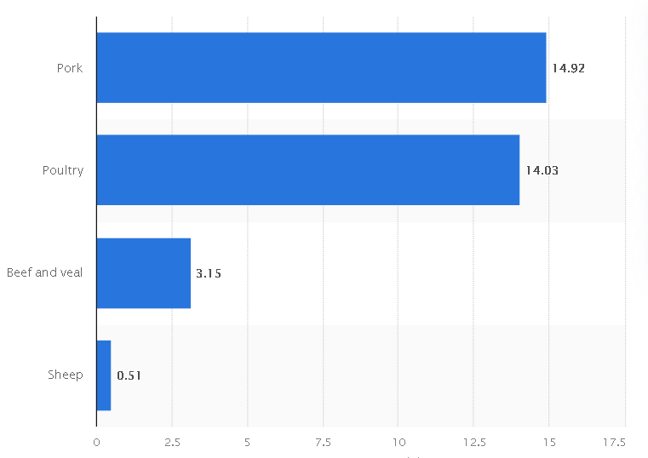

*Figure 1*. Consumption per capita in kilograms  *Source:shorturl.at/dgKNV*

**By Smell/Odor**

This is the simplest method for determining meat deterioration. The meat will have a strong and pungent odor. It will have a terrible, rancid odor.

Raw Beef

Beef should never smell like chlorine, ammonia, or anything else. Someone who does not sniff attentively may not discover anything out of the norm (Case, 2021).

Raw Chicken

Terrible chicken stench. Raw chicken has little to no odor. If the chicken smells like rotting eggs, it is simply spoiled. Never rely just on scent to determine the safety of a chicken. Due to different perceptions of smell, not everyone will perceive a difference in the fragrance of the chicken. Keep an eye out for additional signs of decaying. (Davidson, 2021)

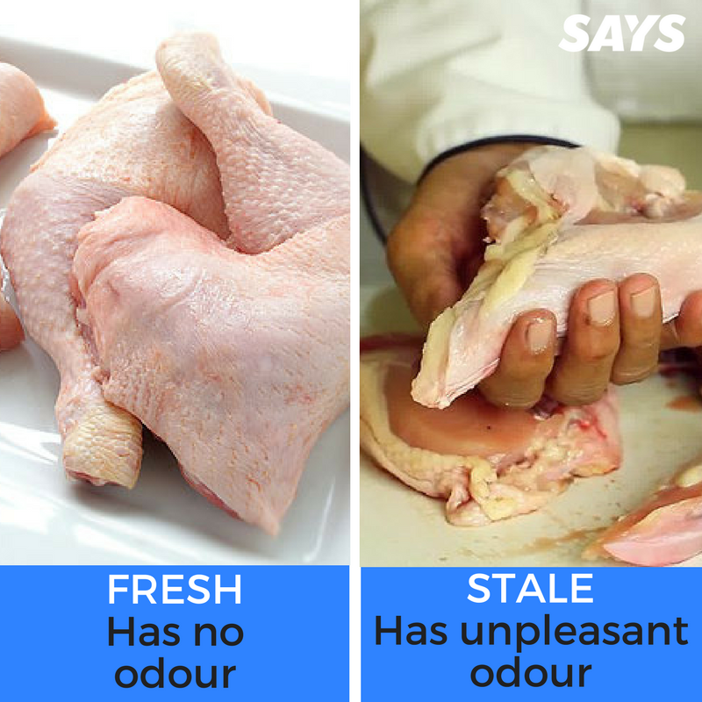

*Figure 2*. Fresh and stale state of chicken  
*Source:shorturl.at/iKLV7*

Raw Pork

Davidson (2021) states that the smell of fresh pork is minimal. Meat goes through structural and chemical changes that cause the smell to vary as it degrades. As stated by (Bob, *How To Tell If Pork Is Bad* 2022), if somehow the pork meat smells like ammonia, fish, gas, or sulfur, then it's unsafe, neither cook nor consume it. Occasionally, packaging, particularly plastic or foam, can impart a foul odor to pork that is not usually indicative of spoilage. If uncertain about what to do, rinse the pork, pat it dry, and smell it again. If the odor has dissipated, it may have been the packaging. If the odor continues, the food will be ruined. (Simply Healthy Family - Team, 2022)

**By Visual Appearance**

Raw Beef

According to Case (2021), red meat, such as beef, should be brilliant red - this indicates that it is at its freshest. Once it becomes purple, it's still OK, but it means it's now been exposed to more oxygen.

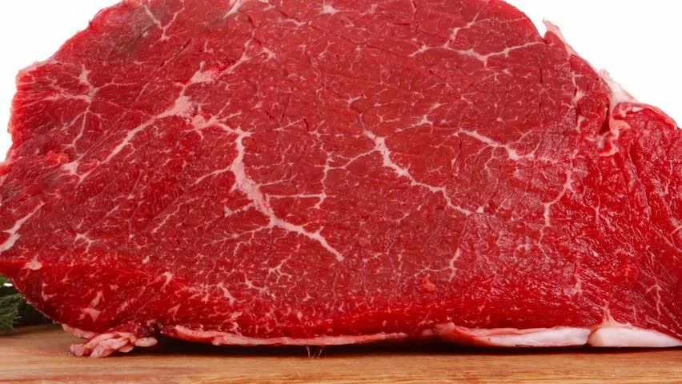

*Figure 3.* Fresh Raw beef

*Source:shorturl.at/aGUW6*

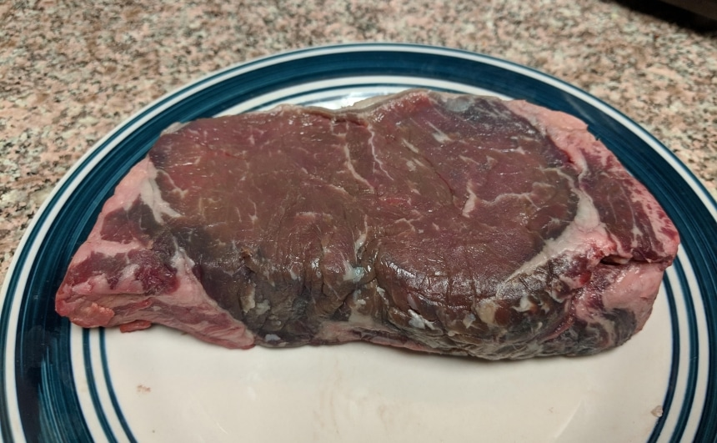

*Figure 4.* Spoiled Raw Beef  
*Source:shorturl.at/dgqEU*

Raw Chicken

Davidson (2021) explains in her article, “How to Tell if Chicken Has Gone Bad” the different physical factors that a consumer should consider in telling whether the chicken meat is good or bad. A fresh fatty raw chicken meat has a light pink color. If the chicken's flesh is gray or green or the fat is yellow, it's spoiled. Mild flesh color changes are usual. When exposed to oxygen, oxymyoglobin, a red protein, and pigment convert to metmyoglobin darkening or fading the pink flesh. This can suggest the chicken isn't as fresh, though not necessarily. Mild color changes are common if the chicken is refrigerated or frozen. If mold is spotted, toss the chicken.

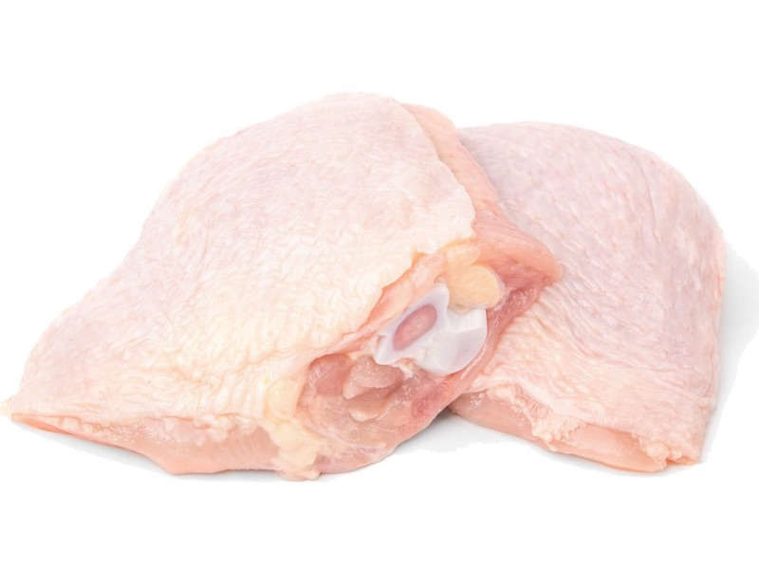

*Figure 5.* Fresh Chicken Appearance  
*Source:https://rb.gy/qnbkma*

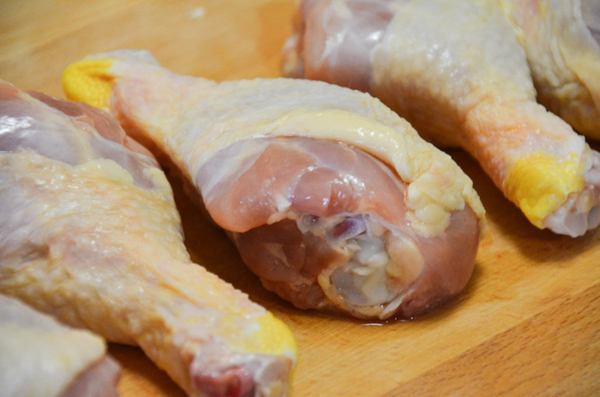

*Figure 6.*  Spoiled Chicken Appearance  
*Source:https://rb.gy/jxutzc*

Raw Pork

As stated by (Bob, How To Tell If Pork Is Bad 2022), knowing how to identify whether pork is spoiled before cooking is essential for avoiding food poisoning. Pork is one of those foods that should not be messed with. A healthy-looking piece of pork will be pink in color. When pork is past its expiration date, its color becomes dull and might seem grayish. The interior may still be pink, but if you see any gray or dulling in hue, throw it out. Fresh pork will be pink in hue, somewhat darker than chicken but lighter than beef. White fat marbling will be present. Another sign that meat has spoiled is if it seems yellowish.

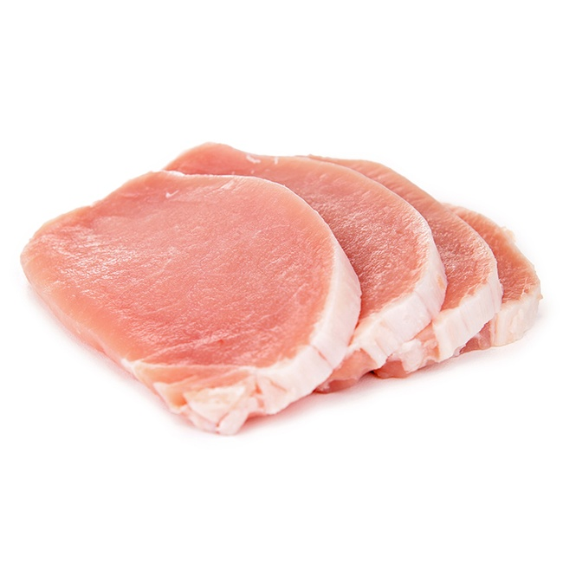

*Figure 7.* Hue of fresh pork  
*Source: https://rb.gy/9bhen1*

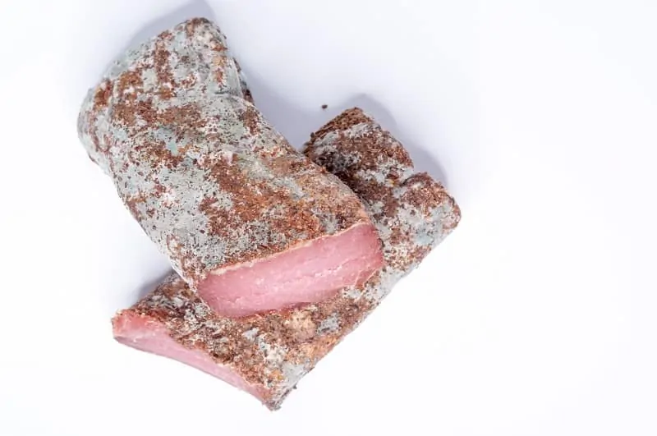

*Figure 8.* Hue of spoiled pork  
*Source:*[*https://rb.gy/eiphxd*](https://rb.gy/eiphxd)

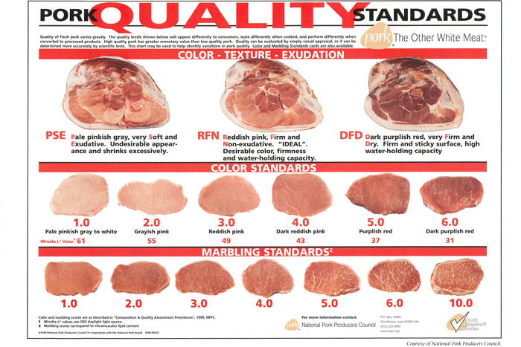

*Figure 9.* Pork Quality Standard Appearance  
*Source: https://rb.gy/ry4qse*

**By Texture**

Raw Beef

To test the level of freshness by texture, firmly press a finger into the meat. If it springs back well, it is new; if not, it is probably old since it is losing its solidness.

Raw Chicken

Glossy, tender raw chicken is fresh. Slimy, sticky, or tacky is unacceptable. If handling raw chicken leaves a slimy residue, it's spoiled. Raw chicken is softer than cooked. If it's squishy, slimy, sticky, or has residue, it's probably no longer safe to eat.

Raw Pork

When buying pork and removing it from the packaging, it may seem a little damp to the touch. This is quite normal. However, if it seems slimy, pork is contaminated and will make one sick if consumed. Another sign that it has gone is if it is dry or mushy. Fresh pork should be moist but firm to the touch similar to chicken breast.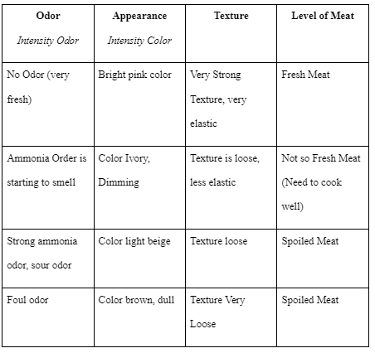

*Figure 10.* Level of Freshness Chart   
*Source: shorturl.at/delZ4*

**Cooked Meat**

According to Monique Lafarte in her blog post *“*[*How to tell if Cooked Meat is Bad - All You Need to Know*](https://cutleryadvisor.com/how-to-tell-if-cooked-meat-is-bad/)*”* (2018), Any poor meat - whether raw or cooked, is a breeding ground for germs including E. coli, Staphylococcus aureus, Bacillus, Salmonella, and Clostridium. These food-borne infections are responsible for millions of instances of poisoning each year. Almost 90% of these instances are the result of ingesting spoiled cooked meat. According to USDA research, if the temperature for preservation is between 40 and 140 degrees Fahrenheit, the number of germs in rotten meat might rise two times every twenty minutes. That is why, in addition to standard testing, you should rigorously test your meat to see if it has gone bad. It is best to use Knives for Cutting Meat to cut the meat. Then you'll be able to have a good peek into the flesh. If you notice slimy pieces or strange places, it is a clue that something is wrong. (Laferte, 2018)

Rancid Odor

Recognizing that meat is rotten after it has been cooked comes with a challenge. However, the most evident sign is putrid odor emanating from cooked meat. Almost most of the time, it indicates that the meat is spoiled. Sniffing the flesh is another way of determining

Mold

When opening a pot of cooked meat and notice that layers of mold have formed on the flesh, it is time to throw it away. If the harmful component is merely detected developing on the meat, most people will cut it out. It is not recommended to consume meat because there is no way of knowing whether or not that form of mold is safe to consume. If fuzzy things are taking over, consumers should just stop eating the whole dish. (Laferte, 2018)

Change in Texture

A change in the texture of cooked meat always indicates that there is a problem. In this scenario, throwing away the entire box is the wisest option.

Slimy Film and Discoloration

Recognizing that meat is rotten after it has been cooked is difficult. However, the most evident sign that it is poor is the presence of sticky film things on the flesh. When cooked meat seems slimy or moist, it is a clear indicator that it is rotten. If you detect a slimy film covering the meat, don't even try to taste it with your tongue. To avoid food poisoning, one might use various methods to taste other than putting the meat into the mouth.

When the color of meat changes, it does not necessarily indicate that it is rotten. Temperature, air, and light may all cause meat to change color. Simple discolorations cannot be detrimental to your meat. However, if the discolouration is accompanied by a sticky or slimy coating, it is a solid clue that something is wrong, and it is best to discard the meat right away.

**Meat Shelf Life**

**Refrigeration**

Beef

Naturally, beef is a widely consumed meal in refrigerators across the world. Many people, however, are unsure if the beef they are purchasing is genuinely fresh. Bacterial growth is the cause of beef deterioration. It is crucial to note that meat does not deteriorate merely because it appears ruined (Schroeder, 2022). Furthermore, consumers fail to predict when the meat in their refrigerator will spoil (Case, 2021).

Red beef and pork can be refrigerated for up to five days and frozen for up until 12 months (Reader's Digest Editors, 2020). Cooked meats, on the other hand, should be stored in an airtight container or plastic bag to keep them moist, and they should be refrigerated within two hours of cooking to avoid the formation of harmful microorganisms. Wrapping meat in plastic or aluminum foil helps keep it from hardening and becoming useless (Paretts, n.d.). Leftover cooked beef will keep in the refrigerator for three to four days and in the freezer for two to six months (Reader's Digest Editors, 2020).

Chicken

Raman, (2019) acknowledged in his article, “*How Long Does Chicken Last in the Fridge?”* that the raw chicken can be stored in your refrigerator for roughly one to two days, as recommended by the Department of Agriculture in the United States. The same warnings should be taken with raw turkey and other types of poultry. In the meantime, chicken that has been cooked can be stored in the refrigerator for roughly three to four days. Store chicken in the freezer if you need it to last more than a few days. A whole chicken can be frozen for up to a year once it is taken out of the package, but raw chicken can be kept in the freezer for as long as nine months. It's possible to freeze cooked chicken for up to six months. Because of the possibility of contamination with bacteria such as Campylobacter, Salmonella, and a host of others, chicken should be avoided if possible.

Pork

According to (Home and Garden Information Center, *Safe Handling of Pork* 2021), look for packages that are cool to the touch and do not show signs of wear or punctures. Always remember to select meat right before you check out at the grocery. Make sure all meats are chilled when purchased, whether raw, pre-packaged, or from the deli. Fresh meats have the potential to infect other food goods. The easiest technique to avoid "cross-contamination" is to keep fresh meats apart from other products at all times. Place raw meat packets in a plastic bag to prevent fluids from dripping onto other items. If you'll be traveling for more than an hour, keep raw meats in an ice chest. During hot weather, keep an ice chest in the car's passenger compartment. Take the meats home and place them in the refrigerator or freezer.

**Cooked**

Beef

It's best not to keep the cooked beef out at room temperature for more than two hours, and to put it in the fridge as soon as possible. Store beef separately from other raw meats, and don't keep them in the fridge for too long-cooked beef can only stay fresh at 40 degrees F or less. Cooked beef should be cooked until the internal temperature reaches 145 degrees Fahrenheit – any lower and the bacteria contained in the raw meat product may not be killed. One of the most often requested food safety issues is how long-cooked beef lasts. If stored properly, cooked beef should last approximately three days before going bad, according to the USDA. Only eat leftovers for one day after they are made if they are not refrigerated promptly – within two hours of preparation. The longer cooked meat stays out, the more likely it is to spoil. If cooked beef is going to be stored for an extended amount of time, it is best to freeze it right away.

Chicken

Cooking fresh chicken thoroughly usually eliminates these pathogens. One should avoid cooking and eating damaged chicken. Toxins created by bacteria cannot be eliminated by re-heating or cooking, and this might cause food poisoning if ingested. Cooked chicken should be white, with no pink pieces of flesh. Pink chicken indicates undercooking. Mold or color changes might be hard to see if poultry has seasonings or sauces. So eat cooked chicken within 3 days. Using a food thermometer, reheat chicken to 165°F (74°C).

Pork

Cooked pork is best kept in the refrigerator for no more than four days. If you do not intend to cook fresh pork within four days after purchase, freeze entire cuts. Before storing, wrap full pieces of pork separately in foil or freezer bags and label to make it easier to pick just the proper amount of cuts to defrost for a single meal. Before freezing, make careful to push the air out of the packaging. If you intend to freeze the pork in its original packaging, cover it with a freezer bag or paper. Unless accompanied by a sauce or gravy, cooked pork slices can be frozen in the same way as fresh. Pack the meat in a hard container with a tight-fitting cover in such an instance.

Avoid putting cooked food on a dish that previously held raw pork without thoroughly cleaning it. Keep hot food above 140° and cold food below 40° Fahrenheit. Never keep raw or cooked meals at room temperature for more than two hours. This is reduced to one hour on a hot day with temperatures of 90 °F or higher.

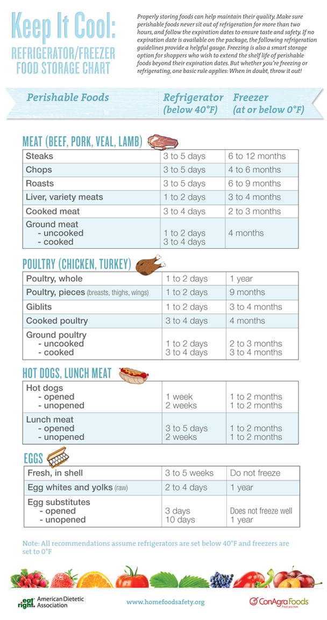

*Figure 11*. Refrigerator/Freezer Food Storage Chart

*Source: shorturl.at/ASUV6*

**Leftover**

Beef

Cooked beef should be stored in an airtight container with a cover. Doing this will keep oxygen out, which can cause oxidation and rancid odors, as well as any microorganisms that may be present on hands or other surfaces when preparing the meal.

Chicken

Chicken leftovers should be refrigerated at 40°F (4°C) or less in a sealed container for 3 days. More than a few hours in the "risk zone" of 40°F to 140°F can cause chicken to deteriorate. This temperature range promotes bacteria growth and foodborne disease. If the chicken develops mold or changes color between when you put it in the fridge and when you plan to eat it, toss it.

Best Refrigerator Rules by Mcneilly in 2022 explains how to determine whether food prepared today can be eaten in the next few days. According to her, Chicken's shelf life can vary from kitchen to kitchen because of different storage circumstances. More than 4 (four) days' worth of chicken can be stored in a refrigerator that is kept at a very low temperature and properly sealed. After 4 (four) days, bacteria normally begins to form on cooked chicken in the average refrigerator, so trash it. Smell and texture can tell you if a piece of meat has been undercooked or overcooked, so keep an eye out for these indications. If any of these characteristics are present, throw away the chicken without even tasting it.

Pork

Leftovers will last in the fridge for three to four days after each reheating. Because the quality of food degrades with each reheating, it is recommended to reheat only what is required. Cooked items that cannot be used within four days should be frozen for safe storage for a longer period of time. Throw aside any food that has been refrigerated for an extended period of time. Never taste food that looks or smells unusual to test whether it can still be used.

**Meat microbial deterioration**

Meat microbial deterioration is a complicated process in which several distinct bacterial populations can play a role depending on storage temperature and packing circumstances. Bacteria's meat-nutrient intake and growth can cause spoiling, resulting in the production of unwanted metabolites. The manner you manage the meat after it's been harvested can have a big influence on the meat's quality. Heat, dirt, and moisture are three variables that lead to ruined meat. A high concentration of decaying meat can have an effect on the health of consumers because it gives off gasses that are the byproduct of the bacteria Clostridium, Bacillus, and Pseudomonas metabolizing the protein in the meat. The process of metabolism will result in the production of various gasses such as Hydrogen Sulfide, Ammonia, Methane, Alcohol, and Volatile Organic Compounds (Remenant et al., 2015). During the process of spoiling, these gas concentrations will increase substantially. The researchers will utilize the chemicals emitted to determine meat freshness though gas sensors using ammonia. Meat's freshness can be determined using the development time of bacteria and the food poisoning index. It is classified into four categories: high, medium, low, and spoiled.

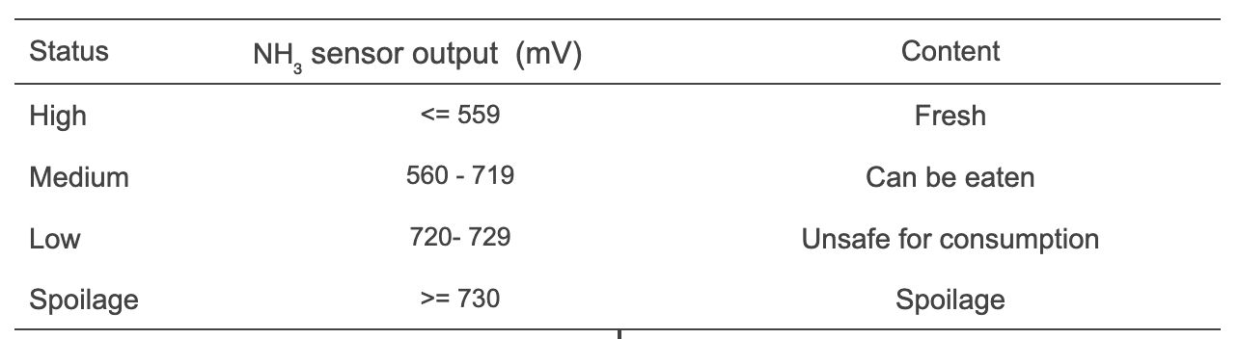

Table 1. NH3 Meat Level of Freshness  
*Source: https://rb.gy/actif4*

**Main Cause of Meat Spoilage**

According to the article posted by Hummel, meat can deteriorate or spoil due to a range of aspects, the most prevalent of which are microorganisms including fungi and other bacteria. Microorganisms in meat cause proteins and lipids to degrade, destroying the meat, or proliferate to unsafe or unpleasant levels for human consumption. Meat degeneration is primarily caused by microbial growth, oxidation, and enzymatic autolysis. Meat is a suitable substrate for microbial growth because of its nutritious composition, high water content, and neutral pH. (Magar, 2021)

[1] After an animal has been slaughtered and butchered, its flesh cells begin to deteriorate and cannot be reproduced. Therefore, meat may spoil if not consumed quickly or stored properly. The meat's chemicals degrade to the point where it is no longer suitable for consumption. Light and heat, for instance, can accelerate this process. Meat can be spoiled by bacteria that were either present in the animal's flesh when it was alive or found a new home after the animal was killed. Any sour, sulfurous, or putrid odor, as well as a rancid flavor or chalky texture, indicate that a bacterial colony has expanded to dangerous levels. [3] Mold can contaminate meat by spreading across its surface in fuzzy or colorful patches that alter the meat's flavor and texture in ways that most people find unpleasant and perceive to be rotten. [4] Improper packing methods can result in oxidation, a chemical reaction that occurs in meat. Meat turns rancid when its lipids react with oxygen molecules, resulting in discolouration as well as a rotting, sour odor and taste. (Hummel, n.d.).

**How Chicken Meat gets Spoiled**

According to (Melissa, *Why chicken goes bad so quickly* 2015), food-borne microorganisms cause deterioration and poisoning. Salmonella, Campylobacter, and E. coli flourish in damp, low-acid conditions with lots of protein; other bacteria, such Acinetobacter and Pseudomonas fluorescens, putida or fragi, thrive on processed meat. Given chicken's specific properties, spoiling is unavoidable and can only be controlled by time, temperature, and moisture. Bacteria require at least 0.85 water activity to grow. Chicken has a water activity of 0.99, making it an optimal food. The water and ice used to prepare chicken don't dry off the flesh after it's washed and chilled, so chicken skin retains more water, creating a home for bacteria. At a population of only approximately 105 cfu/cm2, psychrotrophic bacteria will begin to ruin food; the identifying slime that can build on preserved poultry doesn't show until the spoilage bacteria have reached a significantly greater concentration of at least 3.2 * 107 cfu/cm2. To kill Salmonella and E. coli, chicken must be cooked to 165 degrees Fahrenheit and held there for 15 seconds.

**Average Meat Consumption**

According to the study conducted by the North American Institute (2017), the average meat consumed in the United States by men is 136g or 4.8 oz. and 89g (3.03 oz. In addition, the consumption of meat per Filipino citizen was studied by Statista in 2021 and it showed that Filipino citizens consume around 10.66 kg of pork while 14.05 kg of poultry per capita. Although meat is an excellent protein source, the Department of Health and Social Care advises to cut down to 70g for those that consume more than 90g of cooked processed or red meat a day. The American Cancer Society also recommends 85 to 113g or 3 to 4 oz amount of meat as part of a healthy meal.

**Preventing Foodborne Illness**

As explained by BCcampus (2021), Most cases of food poisoning are preventable with careful handling and preservation of food. Foodborne infections can only proliferate under specific conditions. If the environment and conditions are managed, potentially hazardous bacteria in uncooked or raw food won't be able to thrive, grow, and cause illness. To survive, bacteria eat. Wet, food rich in protein are therefore excellent bacterial development sources. In an acidic environment, bacteria cannot flourish.Since they prevent bacterial development, acidic foods such as lemon juice and vinegar can be used as preservatives.Bacteria thrive in damp environments and need water to survive. Dry, salty meals are safer. Potentially Hazardous Foods encourage the growth or survival of infections or are contaminated with them. They'll decay if stored at room temperature.

In general, a food is a PHF if it contains:

* Milk, crustaceans, meat, eggs, poultry and fish - derived from animals
* Plant material - Heat-treated or cooked
* Fresh sprouts
* Any cooked starch kind
* Soybean protein in any form

**Food Safety Threat in the Philippines**

In establishing the health risks connected with food safety, both the nature and origin of the hazards are considered. According to the research conducted by Rustia et al. (2020), the climate of the Philippines can also influence a number of food safety-related aspects. Normal temperatures in the Philippines range from 25.5° to 28.3° Celsius, which is between 4.44° and 60°, the hazard zone for storage of food. This frequently results in the proliferation of bacterial infections such as Escherichia coli, Campylobacter, Staphylococcus aureus, and Salmonella enteritidis.

The prevalence of spoilage microorganisms and the risk of foodborne illness are both increased by the country's climate, which is prone to high humidity and precipitation. As a result, local food processing enterprises must maintain storage conditions and methods that prevent microorganisms. This study also mentioned that meat-based dishes are a common cause of country’s outbreaks. In contrast, the number of reported cases of foodborne illness attributable to meat-based products and dishes has decreased, which may be related to the implementation of food safety controls like the Philippines’ Meat Inspection Code, which guarantees the safety and quality of meat and meat products through proper preservation, inspection, and importation.

**Foodborne Disease Outbreaks in the Philippines**

Centers for Disease Control and Prevention in the United States described an Outbreak in Foodborne Disease as an occurrence in which at least one or two individuals contract the same illness after consuming a common food source (CDC 2012). Foodborne illness is a global issue, and the globalization of the food trade has increased food safety risks (Choi 2008). Instances of these include epidemics produced by microbial infections, residual contaminants, biological poisons from fishing products, and other chemical and physical contaminants (Spiric et al. 2015). According to the result of this study, there are various factors that can lead to foodborne disease outbreaks. Meat-based dishes are included, (Patricia et al., 2019) stated that the Philippines has issues with tainted meat supplies,as in the case of reported hot meat making its way to a local meat supply chain and the meat-based dishes were among the many foods implicated in the higher incidences of FBDOs (14.35% ). Hot meat is a colloquial term for meat from animals slaughtered in unregistered establishments without the necessary food regulatory inspection (DA 2005). Botcha or double dead meat, which is derived from butchered dead animals, is a worse source of hot meat in the Philippine meat supply (Alonzo 2013). This current study for 2005–2018 has revealed conclusive results. FBDO-related trends were similar from 1995 to 2004. These trends may serve as the foundation for food safety controls. Hopefully, the information offered here will be useful to the nation's system for regulating food safety.

**Foods that contains high in Ammonia**

Ammonia is found everywhere, there’s no escaping; it's one of the most frequently manufactured compounds in the world, and it's also created naturally by our bodies. Pure Ammonia is known as Anhydrous Ammonia and can be found naturally in the environment as a byproduct of bacterial decomposition of organic matter in the soil. According to Shai Cohen (2022), There are probably numerous items that you eat on a daily basis that have significant levels of ammonia in them. As a leavening agent, it is frequently utilized in the baking industry, and in cheeses as an acidity regulator. It is important to be aware of the amount of ammonia that is being taken in through the foods that you eat. Here is a list of ten common meals that contain an unexpectedly high level of ammonia and should be avoided.

1. **Cheese**

It can be found in almost every cuisine on the planet, from paneer in India to Brie in France, to name just two examples. The knowledge that cheese is largely composed of ammonia, on the other hand, is not as widely held as the former. The native blue cheese has the highest concentration of ammonia, with 0.138 grams of the substance present for every one hundred grams of cheese. The amount of ammonia found in beer cheese is 0.092 g, while the amount found in American cheese is 0.081 g and the amount found in Cheddar is 0.11 g.

1. **Onion**

In the dozens of meals that make up the various cuisines of the world, onions are an essential component. The fact that it only contains 0.027 grams of ammonia per one hundred grams of onion is not nearly as appealing as the fact that it has a high antioxidant content and a wide variety of minerals. Even though the concentration of ammonia is quite low, a buildup of the compound might occur over time if onions are consumed on a regular basis. Rather than getting worked up over it, though, all that is required of you is to merely be aware of its event.

1. **Peanut butter**

Peanut butter is an incredible food that can be used in a wide variety of contexts. Peanut butter can be an excellent and nutritious source of protein and healthy fats, provided that it is purchased without any preservatives. In addition to it, however, there is also a trace amount of ammonia present! If you consume 100 grams of peanut butter (which is roughly seven tablespoons), you will take in 0.049 grams of ammonia. This is the equivalent of one part per million (ppm) of ammonia. Therefore, you won't run into any problems if you indulge in this mouthwatering nut butter occasionally and in reasonable amounts. However, we are well aware of how delectably addicting it can be, so please exercise moderation in your consumption of it.

1. **Brewer’s Yeast**

The term "brewer's yeast" may not immediately come to mind, but it is an essential component in the production of beer that is utilized on a massive scale and enjoys phenomenal popularity. Be careful not to go overboard, because 100 grams of brewer's yeast will produce 0.022 grams of ammonia. Taking into account the fact that beer is consumed on a daily basis by a large number of people, it is recommended that you drink your beers in moderation.

1. **Potato Chips**

Most potato chips are made the same way. A generic 100-g bag of potato chips is thought to have 0.024 g of ammonia in it. You're right if you thought that the amount of ammonia here isn't that high. But think about what it means to snack on potato chips. If you take out a bag while watching a movie or a lot of episodes of a TV show, it will be gone before you know it. Potato chips are easy to eat without thinking, so you might end up eating a lot more than you planned. If you eat potato chips as a treat or snack every day, you may have eaten more ammonia than you should have. Because of this and the fact that potato chips have a lot of sodium and saturated fat, you should try to eat them less often.

1. **Gelatin**

Gelatin is made from the collagen in crushed animal bones, and its high glutinous content causes it to solidify into a transparent gel. The ammonia comes into play now. Ammonia, as you may recall from before, is a byproduct of animal degradation; hence, gelatin is also a byproduct of ammonia. About 0.035 grams of ammonia can be found in every 100 grams of gelatin.

1. **Salami**

These slices of cured, fermented sausage are a typical addition to any cheese board, but they also go great on sandwiches, pasta, salads, and pizzas. However, watch out: on average, salami has 0.11 g of ammonia per 100 g.

1. **Margarine**

Historically, margarine has been marketed as a healthier substitute for butter, but ultimately, the decision to use one over the other is up to the individual. With only 0.021 g of ammonia per 100 g, the infrequent consumption of margarine is unlikely to have any negative health effects. But if you use margarine as a substitute for butter in three meals a day, plus while baking and frying, the ammonia may pile up quickly.

1. **Mayonnaise**

People tend to feel strongly one way or the other about mayonnaise. Mayonnaise has 0.041 g of ammonia per 100 g, so if you're not a fan, you can skip this part. But if you are, you might want to know. Although it may not seem like much, consider how often mayonnaise is liberally applied to burgers, slathered on sandwiches, and used as a dip for fries.

1. **Ketchup**

Ketchup is the foundation for a broad variety of different sauces, so it's possible that you're ingesting it without even recognizing it. Approximately 0.035 grams of ammonia can be found in every 100 grams of ketchup. Even though this is a smaller amount of ketchup than mayonnaise, any reduction in use is welcome.

**Ammonia**

*What is ammonia?*

One of the most widely manufactured compounds in the USA is ammonia. Anhydrous ammonia is the term used to describe the substance in its purest state. Ammonia can be found naturally and is created by the body. It serves as a fundamental component in the synthesis of proteins and other complex compounds in the body. Ammonia is a naturally occurring gas produced by microorganisms in soil. It's also created during the decomposition of plant matter, animal matter, and animal feces.

*How does ammonia act in the body?*

Ammonia is converted to harmful ammonium hydroxide when it comes into contact with water in the body through inhalation, ingestion, or skin. This substance is highly corrosive, and it kills or severely destroys living cells the moment it comes into touch with them.

*What are the specific signs and symptoms of ammonia poisoning?*

When exposed to oxygen, ammonia may eat away at metal. The method of exposure, the dose, and the duration of exposure all play a role in how severely a person's health is affected. High levels of ammonia in the air can cause severe burns to the respiratory system, eyes, and nose, and could lead to blindness, lung damage, or death if the person is exposed to it for too long. Coughing and discomfort of the nose and throat can result from even minimal exposure.

Burns to the mouth, throat, and stomach can result from ingesting ammonia. In addition to causing discomfort and burns if it comes in contact with the skin or eyes, excessive ammonia can also produce a chemical reaction.

**Ethylene, The Gas That Rots Your Fruits & Vegetables**

According to Green tip (2021), all plants matter, including fruit and vegetables, gives off ethylene. This hormone in plants is made from the amino acid methionine and plays a crucial role in ripening. It improves the taste, appearance, and/or texture of produce. In fact, it reduces their acidity and starch while increasing their sugar content and eliminating whatever contaminants they may have contained.

Plants can continue to ripen even after they've been harvested, a process that can result in the continued production of ethylene. Therefore, climacteric plants are those that require ethylene to reach maturity. Also, certain plants release abnormally high levels of ethylene. In this way, ethylene gas causes the slow deterioration of perishable foods like fruits and vegetables. Learning how to conserve plants and storing them properly can significantly postpone their decomposition.

*Climacteric plants:*

Among the plants that produce ethylene in large quantities, they found::

* bananas
* apples
* mangoes
* melons
* watermelons
* avocados
* plums
* grapes
* tomatoes
* And finally, onions.

These plants should not be stored with those that are sensitive to ethylene, which are listed below:

* Broccoli
* Lettuce
* Asparagus
* Potatoes
* Cucumbers
* Carrots.

**Mobile Application**

According to Techopedia (2020), also referred to as an app, is a program built for smartphones, tablets, and other mobile devices. Mobile Applications are mostly small, standalone devices allow users to access services similar to what is available on web or PCs.

**Android**

According to Britannica (2020), Android is a mobile operating system developed by Google. It was initially owned by Android Inc, which aimed to create operating systems for cameras. It was only in 2004 that Android was bought by Google, a search engine company. Devices that are based on Android utilizes Android Package Kit, or APK for the installation and distribution of mobile applications. The file format compresses multiple files that make up an application. APK files allow users access to applications more than what is available online and also test beta applications that help solve everyday problems in a community (Montegriffo, 2022).

**Android Studio**

The Android Developers (2022) website discussed the objectives, design, and development of the Android Studio. This online platform utilizes IntelliJ IDEA and the official Integrated Development Environment for Android. It is designed to help with the development of applications for Android devices. It also has a feature that allows users to update current resources without restarting the application. With this, users can test and deploy gradual changes without affecting the status of the device.

**Automatic Food (RAW) Spoilage Detection**

As argued by Kumar (2018), the construction of adaptable sensors has been investigated to extend creative devices with the need in many machinery scopes, such as food safety. Foodborne illness is one of the most serious health concerns. This research has developed a hybrid technique that can provide accurate information on the consistency of food during storage. Smart bowls use a variety of sensors to document the advancement of characteristics such as the number of microorganism agents, gasses, temperature, humidity, and storage duration to track the consistency and preservation of food products. The device mentioned in this research study is a food detection technology that detects the quality of food in real time. A proximity sensor is installed at the outer portion of the bowl to detect the incoming individual to fill the food, and a food control tool is installed to verify the consistency of food control tools as soon as the incoming detected bowl lid is opened for filling. The capacity sensor checks the bowl limit till the user fills it, then instructs the user to fill the restricted set food container. After filling the container, the mounted sensors such as the PH sensor, the humidity sensor, and the MQ4 methane gas sensor start checking the quality of food, where the PH sensor checks the food's PH value, the humidity sensor checks the food's darkness, and the MQ4 sensor checks the gas emitted from the food after filling. In addition to real-time applications, this device contains an Android application that allows the user to obtain food quality statistics and information. The bowl-mounted device is inexpensive, compact, and prevents individuals and groups from becoming infected by contaminated food.

**Evaluation of chicken flesh bacterial population utilizing a suitcase electronic nose**

A study of Timsorn et al. in 2016 proposed using an e-nose based on Metal oxide semiconductor sensors to determine if the chicken should be eaten or discarded by testing how well chicken kept at 4.0° and 30.0° Celsius for as long as five days holds up in terms of freshness and bacterial population. Comparable to the interaction between primary neurons in the nasal canal and chemical sensors in the nose, the e-nose technology comprises a number of electrochemical sensors and pattern classification algorithms that can detect the gas emitted. The authors used principal component analysis for pattern classification and recognition to demonstrate the category of pig meat freshness based on varying storage, days, and temperatures.In conclusion, the e-nose showed a strong correlation of 0.94 with the population of bacteria in chicken, indicating that it can be used as a quick and alternative approach for evaluating bacterial population in meats. It is affordable, portable, accurate, and non-destructive.

**User-friendly sensor for quick bacterial deterioration detection in packaged meat products**

According to the research of Abo Dena et al. (2021), High-perishability foods include meat and many other types of food. In addition to H2O, meat products also have complex biomolecules, rendering them susceptible to microbial contamination and lipid oxidation. Fresh meat that quickly spoils and loses its quality poses health concerns to consumers and economic costs to producers. This study presents a colorimetric sensor for quantifying deterioration of meat. This device led to the development of other sensor designs, including pH detectors, freshness indicators, carbon dioxide, and oxygen. Moreover, gasses created by food can be employed for checking its quality. Consequently, several sensors fabricated using optical dyes have been used to measure gas products emitted by damaged meat. Bromocresol purple and bromothymol blue were used to construct the proposed sensor. The creation of an application for identifying and quantifying bacteria in samples of damaged chicken meat. The sensor was tested to detect deterioration in actual meat samples (chicken) at cooler and normal temperature, and it can be used to make intelligent meat-packaging films. The application generates a curve for calibration from standard photos to microbiologically compute the samples and compares the results to the standard. The application then displays a notification reflecting the freshness level, which ranges from poor to excellent.

**A Review of Meat spoilage sensors based on polymer**

According to this study, conditions of Food storage along the cold chain must be governed by intelligent packaging. Throughout its life cycle, Intelligent Packaging monitors the condition of packaged commodities used to send information such as quality and safety of food. Environmental changes and microbiological attacks account for the majority of the worldwide IP industry. Intelligent packaging may also improve food safety and convenience.

As part of smart packaging, gas sensors can pick up on some of the gasses that spoiled food gives off at the start of the decay process.

It also states that the poultry,fish, and meat spoilage is closely related to enhanced nitrogen-containing compound synthesis. Ammonia volatile, on the other hand, has the most significant intensity of odor emission.This study's primary objective is to investigate the ammonia volatile in decomposing food. A gas sensor is composed of a chemical that is sensitive to gas that initiates reaction in the presence of the gas at the specified temperature.

This article asserts that great progress has been made in past years in the development of gas sensors that are polymer based for rapid and precise detection of volatiles at the onset of decay. Many researchers are interested in the process; the number of polymer gas sensor papers is rising annually (2010 to 2020), indicating that polymers have garnered more interest in current gas sensor technology development.

This study's primary objective was to evaluate sensors that are polymeric for sensing spoilage of food by measuring gas concentrations within food packaging. Systems of Cold chain management control perishable commodities based on organic, monolithic, and purposeful technology meant to manage perishable food products. As explained by this study, in the early stages of food decay and the production of organic compounds, predominantly Ammonia is present. The kind of food affects the microbial growth and metabolic changes. Utilizing an electronic equipment to identify these emitted vapors is a rapid and effective method for tracing food quality management. Polymers can be used well for manufacturing in this regard. Intelligent food packaging would benefit from multiple gas sensors with minimal power consumption. This study categorizes gas sensing methods and examines sensing principles polymer gas sensor properties. It is demonstrated that the production of polymeric composite materials improves the performance of sensors in the presence of a gas.

**Characterization of meat spoilage mechanisms by Brochothrix thermosphacta**

Microbial spoilage of food causes serious economic damage around the world. This is due to the development and metabolism of microorganisms that produce unwanted odors, flavors, textures, or colors. One of the most common types of spoilage bacteria in meat and seafood is called Brochothrix thermosphacta. It produces a variety of metabolites that cause stinks that may depend on strains, food types, and the bacterial communities that surround them.. The evaluated genetic and phenotypic diversity of B. Thermosphacta included in a stock collection of various origins ( meat, dairy, environment) using different methods were used to subdivide the tribe into different groups, revealing important diversity. However, intraspecific diversity has nothing to do with the environment in which the strain was isolated. Point mutations may explain the various abilities to produce putrefactive molecules. Transcriptomics studies have shown that genes that are differentially expressed in a fish or meat matrix encode important functions for growth and survival in these particular niches. Volatile analysis in B. Thermosphacta has shown that thermosphacta produces a variety of molecules that cause different stinks depending on the growth matrix. Therefore, it showed a matrix effect rather than a stress effect on the potential putrefaction of B. thermosphacta.

# **Specific Heat Capacity Estimation for Foods and Lipids**

According to this study in 2018, the contribution of the lipid component to the composition influences the specific heat capacity of foods containing moderate to substantial levels of lipid.The fatty acid content of the lipid fraction may affect its specific heat capacity. Despite the fact that established methods for predicting specific heat capacity based on composition produce good predictions, it is obvious that there is room for improvement. As stated, utilizing modern specific heat capacity measuring techniques, such as Modified Differential Scanning Calorimetry, the inquiry quantified the possible effect of fatty acid content on the specific heat capacity of dietary lipids. MDSC assessed the specific heat of triacylglycerols (TAG) between 40 and 130 degrees Celsius. The following parameters were used to describe the composition TAG fatty acid: the first is the number of double bonds on average, and the second is the average amount of carbon atoms. In each case, their effect on the heat capacity was established. Using the specific heat of TAG, a model for estimating the specific heat of dietary lipids as a function of Double Bonds, Carbon atoms, and temperature has been developed. It was determined that the temperature influence on the specific heat capacity is linear, and that the same holds true for liquid TAG. Carbon atoms and double bonds improve liquid TAG's capacity. The proposed model predicted vegetable oil specific heat capacity with a relative inaccuracy of 0.83 percent. As long as the parameters are adequately regressed, the group contribution method has proven to be an excellent tool for forecasting the specific heat capacity of dietary lipids.

# **Evaluation of the Taste and Texture of Meat Using an Electronic Nose**

The electronic nose comprises an array of chemical sensing devices and a computer, as well as a sensor array. The study explains the many types of chemical sensors utilized in electronic noses, particularly the sensory sensors. A chemical sensor converts a chemical amount into an electrical signal and responds to the concentration of certain particles in a gas or liquid. Physical sensors differ greatly from chemical sensors. Physical sensors can record approximately one hundred physical parameters, whereas chemical sensors can record orders of magnitude more. The chemical sensors utilized by E-nose must detect odor molecules in the gas phase. Typically, these molecules are organic compounds that are volatile with varying molecular weights. The majority of manufacturers seek sensors with excellent selectivity. Each component present in the gas phase must be detected by at least one sensor for electronic noses. A minimum of one sensor must detect the addition of a new component to a mixture. If you employ an excessive number of sensors, your system will be complicated and produce a great deal of needless data. Although various types of gas sensors are accessible, only four technologies are currently utilized in electronic noses: piezoelectric crystal, MOSFET; CP; and Metal oxide semiconductor.

**SERS sensors for quick on-site fish and meat quality control**

Surface Enhanced Raman spectroscopy, is one of the essential on-site testing instruments. Due to their extraordinarily complex chemical compositions, the probable presence of unknown microbes, and the difficulties of directly acquiring spectra information from within the product, onsite safety evaluation of fish and meat products remains a significant problem for SERS. Through electrochemical nano-etching of commercial Ag needles, this paper presents a practical method for the mass production of a unique SERS sensor type. The resulting SERS sensor possesses abundant surface nanostructures with ultrahigh SERS sensitivity, rendering it extremely suitable with portable and affordable Raman spectrometers for detection onsite. The sensors can measure proteins, lipids, and purine. The novel sensor has a nano-engraved plasmon surface structure that is very resistant to aggregation and material loss, making it appropriate for depth profiling applications. In this study, optimal durability is also significantly enhanced. These sensors may be frequently regenerated using acid rinsing while retaining a strong amplification effect. The new sensors introduced in this literature offer a promising method for rapid, low-cost, and easily accessible on-site quality inspection of perishable foods including fish and meat.

# **ForceSpun nanofibers as sensors for food spoilage**

# As a result of health and economic concerns, the safety management of foods, especially seafood and meat, are receiving more focus. Meat protein degradation generates Biogenic Amines and Ammonia including cadaverine, trimethylamine, and putrescine. In order to evaluate the meat quality of products during transit, consumption, and storage it is necessary to detect BA with high sensitivity. In this study, reinforced Silica polydiacetylene nanosized fiber mats were created using a new Forcespinning® technique. Strong electrostatic contact between the carboxylic acid ion of PDA and the amine ion of the BA molecule enables the optical detection of BA by these PDA nanofibers.In addition to blue-toned color changes, PDA nanofibers cause an increase in fluorescence. The amine detection characteristics of PDA nano fibers made from two distinct monomers were examined and compared .PDA nano fibers fabricated from ECDA demonstrate great performance and measure amine vapor concentration in minutes with a detection limit of around 7 ppm. When testing the capability of nanofibers to detect BA vapors in truly perishable meat items such as cattle, chicken, pork, and fish, effective colorimetric responses were also achieved. Overall, force spinned PDA nano fibers showed great colorimetric meat deterioration detection based on vapors. These nanofibers can be used to detect meat deterioration and freshness in real time.

**eFresh - Device to Detect Food Freshness**

The food we eat can have an impact on our health in several ways. Improper storage and chemical use for alterations in food may lead to contamination. There are various types of viruses and microorganisms that contaminate food and cause various food borne illnesses, such as Norovirus, a highly infectious virus generated by tainted food or water. Food poisoning kills over 351,000 individuals worldwide annually. The majority of people in Pakistan are Muslim, therefore, everyday challenges for food due to the maintenance of foods and the use of chemicals to extend time artificially tend to make the people get sick.(Naveed et al., 2018), developed a smart system that can detect food freshness using biosensors and electrical sensors .Farm products, meat, and fruits are examples. The recognition and moisture, and hydrogen ion concentration device. The gas sensor is utilized to make a smart food freshness detector in ensuring food freshness and determines whether it should be eaten or discarded. An application for Android is designed to choose the type of food to be examined. The system guarantees that the food is safe to consume. It does not allow you to make a complaint if the device does not produce accurate findings.

# **Home cooking and storage practices influence pork-related Salmonella and Listeria exposure.**

# According to this report, most consumed meat in the European Union is pork meat, and controlling the health and economic concerns associated with pork consumption is of crucial importance. Pork has the potential to expose consumers to 27 biological risks. Listeria monocytogene, Salmonella enterica, Yersinia enterocolitica, and thermophilic Campylobacter possess the greatest risk scores. This study aimed to determine how different cooking methods and temperatures affected the presence of Salmonella and Listeria in pork loin chops. The loin chop of pork must be prepared before it is consumed. It is generally known that heating meat to 70 °C for at least 2 minutes will kill bacteria. In addition, the British Retail Consortium of Britain guideline specifies "cook" as a heat treatment that results in a 6 log10 drop in L. monocytogenes efficiency, which is approximately 70 degrees Celsius for 2 minutes. If pathogen cells survive boiling and cooling, they may thrive in the refrigerator and at room temperature. Consequently, cooking time, and temperature may vary significantly based on the product and cooking method. Multiple studies show that sensory alterations affect customers' preferences on cooking. In this regard, the Microbiological Safety of Foods Committee warns of potential consumer risks that come with recent modifications in cooking, namely the practice of serving ‘rare’ food items. Handling leftover meat after processing may be a source of contamination and disease proliferation. According to Gong et al. (18), 48.7 % of Chinese customers store meat at room temperature, 48.1 % refrigerate it after a meal, and 3% throw it away. It concluded that Salmonella and L. monocytogenes in cooked pork meat was rendered inactive by the cooking combination "oven well-done.", resulting in no consumer exposure following meat leftover storage. Other cooking combinations enabled constant temperatures of the product of 73.6 Celsius, reducing both pathogens between 6 and 7 cfu/ gram. The data gained may be immediately applied in risk assessment models and consumer advice on best techniques for preparing pork meat at home.

A mobile application, commonly known as an app, is a software that runs on mobile devices such as smartphones and tablets, according to Techopedia (2020). Frequently, mobile applications offer functions comparable to those available on desktop computers. By using a mobile application, the data from the Food Spoilage Detector can be accessed easily through a small, standalone software unit like smartphones and tablet devices.

**Conceptual Model of the Study**

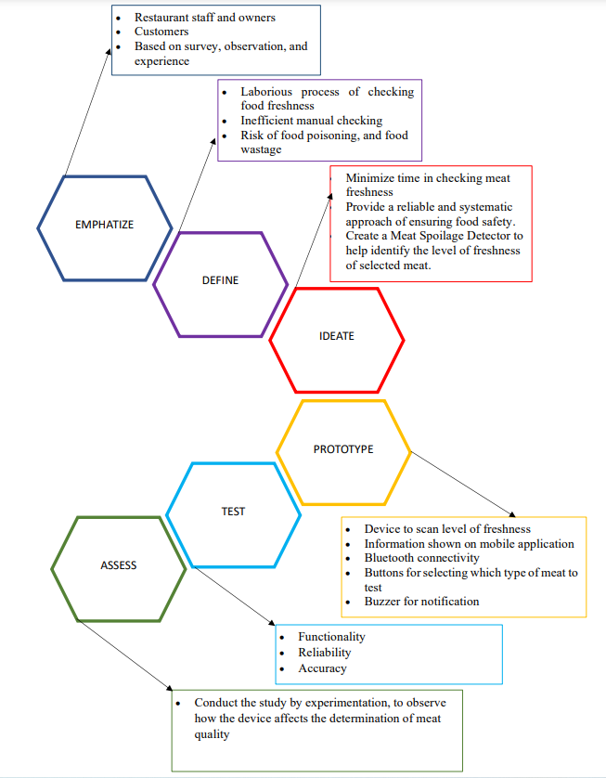

*Figure 12*. Design Thinking Model Diagram

Through small research conducted by the researchers on selected meat restaurants, it was found that the restaurant staff had to go through the process of determining the level of freshness of pork, beef, and chicken supplies by manually checking the meats through smell and touch. This process proved to be an inefficient way of dealing with the meat supply since the level of freshness is limited to the staff’s judgment and due to the way it was manually checked, it often caused contamination that also led to spoilage of the meat products. In addition, although this may work in smaller establishments, it may not be as effective when adapted to bigger establishments causing hindrance to business growth.

Ensuring that the restaurant provides good quality dishes and products to the customers was a challenge for the restaurant staff. The process of checking food freshness was laborious and affected the time for customer service since food must be in good condition before it is presented to avoid food poisoning, food wastage, and bad business reputation if a situation has occurred. For the customers, dining in restaurants poses a greater risk of foodborne illnesses, especially when they unknowingly eat dishes that are nearing spoilage. The proposed solution of the researchers for this problem was to utilize a food spoilage detector, a convenient way to keep track of meat spoilage, which gave the restaurant a reliable and systematic approach of ensuring food safety, giving more time for staff to provide excellent work performance and customer service.

The Food Spoilage Detector helped to identify the level of freshness of selected meat, in this case - pork, chicken, and beef. The device was also used to distinguish the status of meat in raw and cooked conditions. In addition, manually checking the meat status can be time-consuming. The Food Spoilage Detector provided less biased and faster results in determining food quality. Information on the quality can be seen through the mobile application.

The researchers planned to create a device that interacts with a mobile application that can tell if the sample meat, cooked or raw, is spoiled. Through USB connection, the mobile application acts as the main system that shows the results of the data gathered from the device gas sensors. The light emitting diode indicates whether the device is detecting the meat quality is fresh or not. The device has four buttons, aside from the power button, the three buttons are labeled as pork, beef, and chicken that the user can use for choosing what type of meat they will be scanning. Once scanned, the information was displayed on the mobile application. The device also has a buzzer that will alert the user that the device has already scanned the sample meat through a beep sound.

The researchers aimed to conduct the study by experimentation, to observe how the device affects the assessment of quality of meat in the food establishment it is used. To measure the efficiency of the meat spoilage device, the researchers also conducted a survey to measure how effective the application and device were for the customers, restaurant owners, and their employees. This helped the researchers to determine if there was a need for improvements based on the respondent’s insights to the study.

**Operational Definition of Terms**

**Ammonia** - refers to a compound of hydrogen and Nitrogen that emits a pungent smell and is usually colorless.

**Android** - refers to the mobile operating system developed by Google and is used mainly for cell phones, tablets and other touchscreen devices.

**Android device -** refers to devices that run on a mobile operating system called android Android.

**Android Package Kit -** also known as APK, is used as the file format on applications that run on Android operating system

**E-nose / Electronic Nose** - designed to pick up on subtle nuances in flavor and aroma. "Electronic sensing" describes the ability to simulate human perception by means of sensors and computerized pattern recognition software.

**Foodborne Diseases -** means sicknesses brought on by ingesting poisonous substances. There are numerous kinds of foodborne illnesses because foods can be contaminated by so many different kinds of disease-causing organisms or pathogens. Infections from parasites, viruses, and bacteria account for the vast majority of cases of food poisoning.

**Food spoilage -** refers to the process where a consumable product becomes unfit for consumption due to packaging and storage.

**Food spoilage detector** - refers to different types of gas sensor that detects several toxic gasses that emits from spoiled raw and cooked food

**Gas sensor array** - also referred to as GSA, is used to measure when a smell is made up of a variety of gasses. Provides greater performance than a single sensor due to better concentration measurement.

**Mobile Application** - refers to a piece of software that can only be used on a mobile device, like a smartphone or tablet.

**Meat Quality -** described as a scale against which the qualities and characteristics of meat are compared and contrasted to arrive at a final verdict on its acceptability for human consumption.

**PPM -** also known as the abbreviation for parts-per-million, is the measurement of important low levels of concentration. This can also be measured as milligrams per liter (mg/L).

**Restaurant -** refers to a business where customers pay to sit down and consume food prepared and/or served by the proprietor.

**Semiconductor Sensor** - refers to a component produced on silicon wafers having reverse bias operation, low capacitance, and leakage current.

**Smartphones** - refers to a device with an operating system that is able to download applications and can be used to connect on the internet and cellular network.

**User Interface** - refers to the point of contact humans use to interact with an application, computer, or website .

**Chapter 3**

**METHODOLOGY**

This chapter displayed the block, isometric, and process flow diagrams associated with the concept of the study.This also included detailed drawings and methods for the manufacturing of the prototype. The evaluation, operational, and testing procedures were also given.

**Project Design**

The Food Spoilage Device was shown in isometric form in Figure 13. The main components that the researchers will use in this project are MQ135, and MQ-137 from the MQ family of gas sensors. These gas sensors use a standard gas detector to recognize several harmful chemicals emitted by damaged food, such as ammonia or ammonium (NH3/NH4), methane (CH4), alcohol, and hydrogen sulfide (H2S).It will link the device to the meat supplied in the Samgyupsal restaurants. One of the primary components is the Arduino Nano, which is a programmable open-source microcontroller board that will control all of the components linked to its board. The Lithium-ion battery, which acts as the standalone device's power source. Moreover, the mobile application must be able to develop and work as a device companion. The remaining components will be covered on the following page of the document.

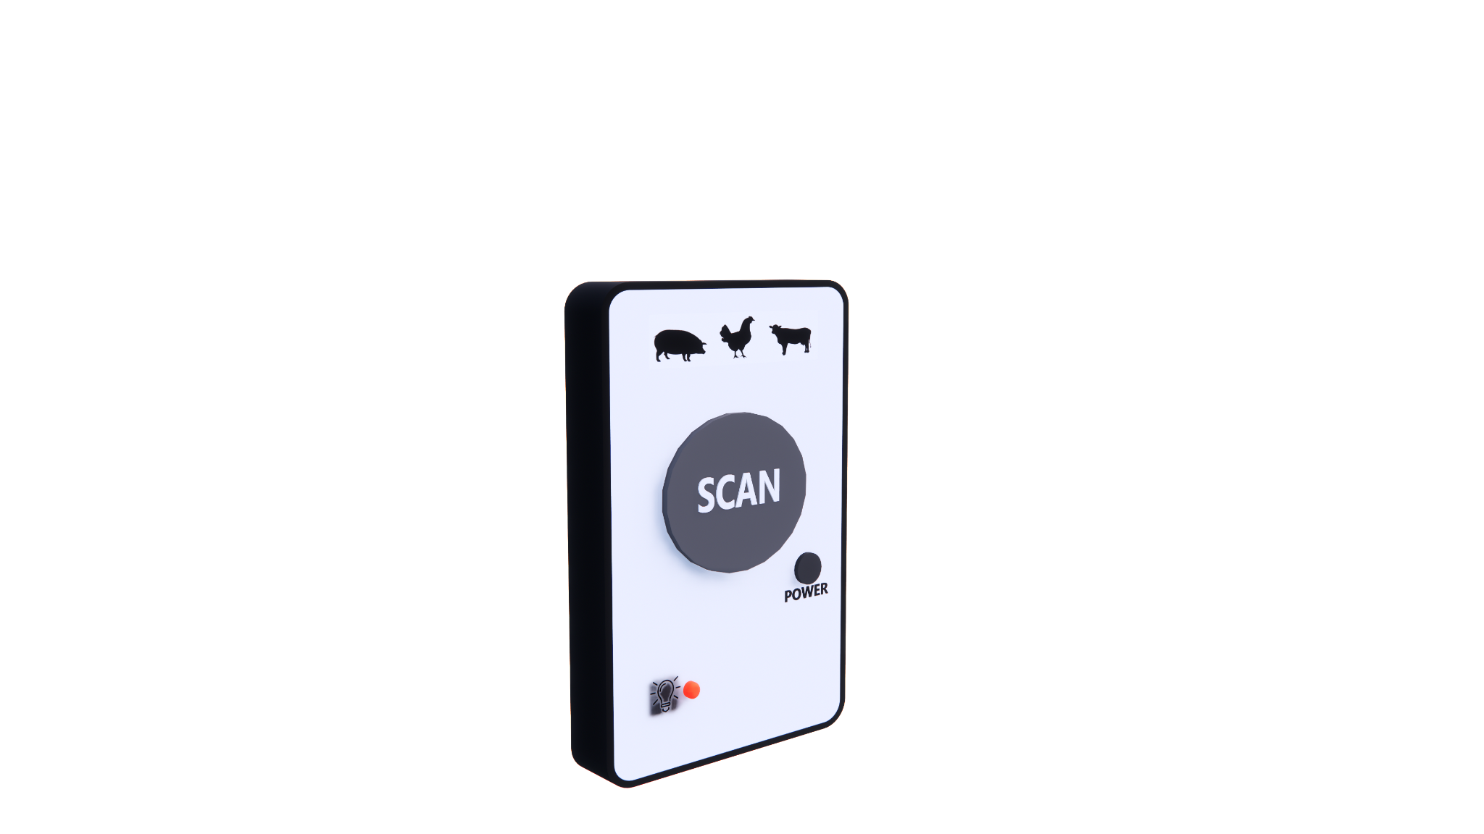

*Figure 13.* Isometric View of Food Spoilage Detector

**Mobile Application**

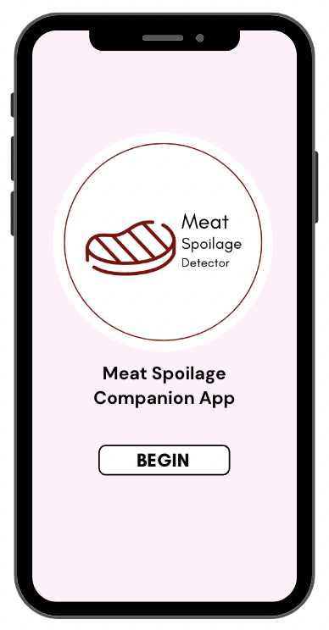

*Figure 14*. Main Screen

Figure 14 illustrates the main interface, where the app begins to load, as well as a clickable button to begin utilizing the companion app and the device. The device will then transfer its data to the app through a USB-C cable on both ends in order to present the outcome of the device's scanned result.

|  |  |
| --- | --- |

*Figure 15*. Device for connecting page | *Figure 16.* Connected device page

Figure 15 shows whether or not the device is connected to the phone. If the device is connected, it will appear on the screen of available devices, as shown in Figure 16.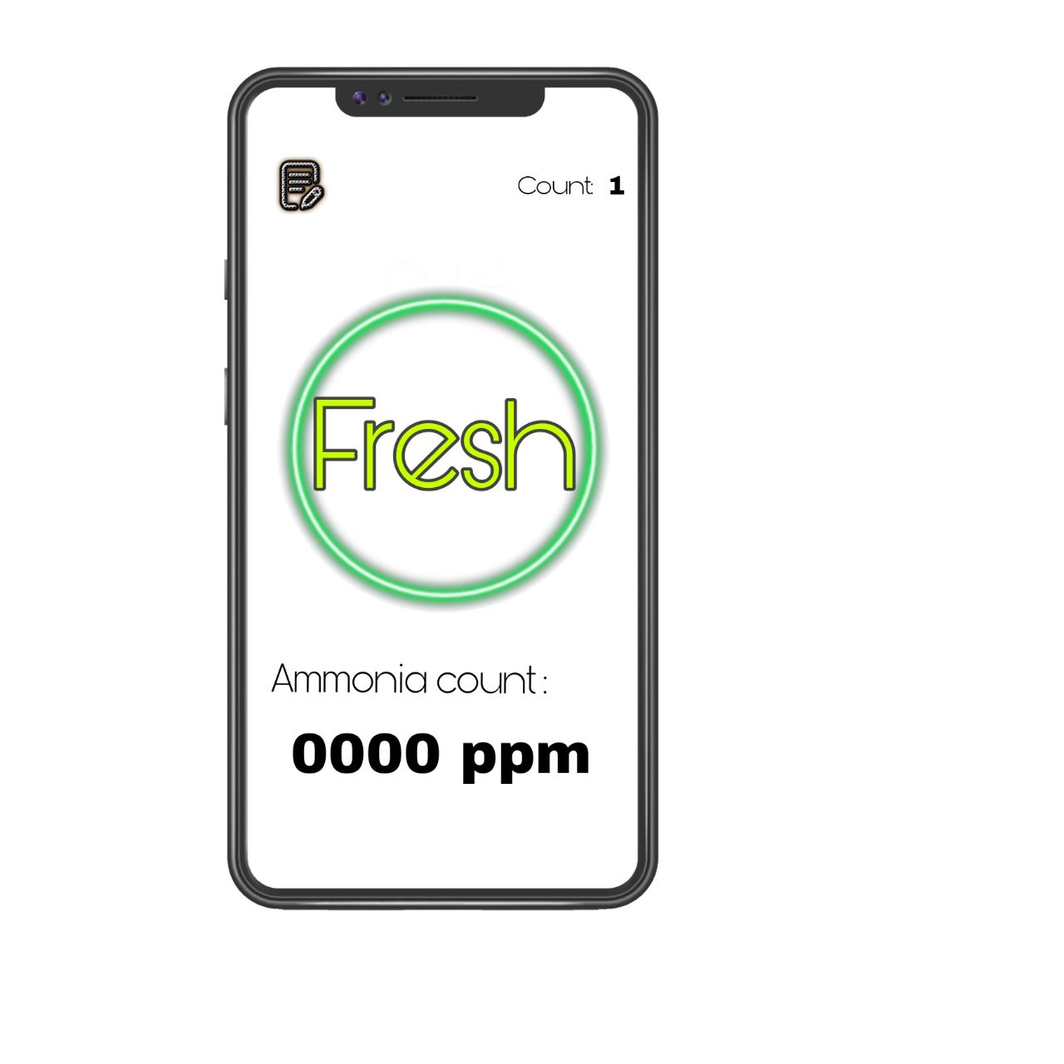

|  |  |  |
| --- | --- | --- |

*Figure 17*. Brief Instruction Page

Figure 17 shows the brief instructions for using the linked device.

|  |  |  |
| --- | --- | --- |

*Figure 18.* Output Application Display

(from left to right; FRESH, NOT SO FRESH, SPOILED DISPLAY)

After analyzing the meat and processing the data, the picture display changes depending on the category of meat, with green representing fresh meat, orange suggesting not so fresh meat with a sub category for safe and unsafe, and red indicating spoiled meat (see Figure 18). The number of scans and other outputs gathered on the device, such as the date, values, and purchase location, will be displayed on the history page by clicking the "view record" button in the top right corner of the display.

|  |  |
| --- | --- |

*Figure 19.* History Page | *Figure 20.* Edit page

The total count of each category—fresh, not so fresh, and spoiled—as well as the history of every transaction is shown in Figure 19. The history page displays the date and time, the status, the value, the store where the meat was purchased, and a comment about who scanned the device. Additionally, there are two buttons that let you choose between deleting it and editing the desired row or a “clear all” button to delete the entire history page. The user will be taken to the edit page as illustrated in Figure 20 as soon as they click the edit button on the history page. The entire edit page will display the date, time, meat status, values, and place of purchase. Only the comment box can be changed by the user, and there are only two buttons: one to save all changes and the other to undo them.

**Block Diagram**

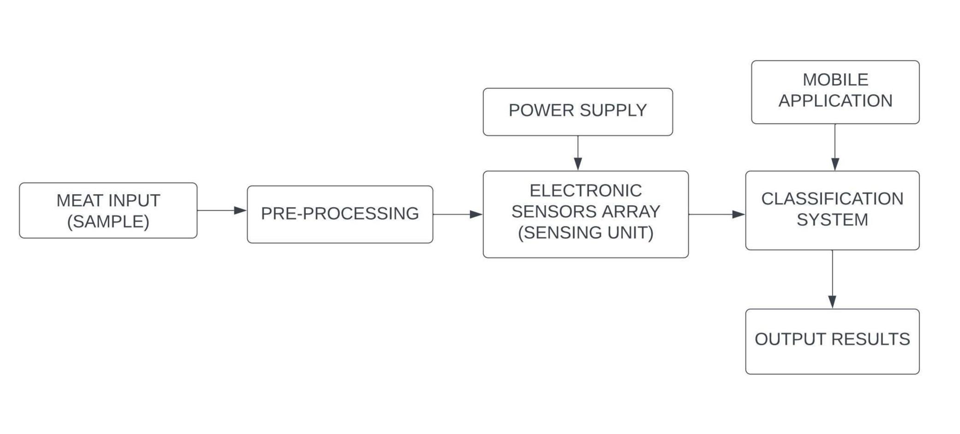

*Figure 21*. Block Diagram of the Food Spoilage Detector

Figure 21 showed the flow of data from acquisition to results. The input was collected from the sample meat through a hand-held spoilage detector. The gasses detected from the sample meat were analyzed by the gas sensor array, which was powered using the power supply. In the classification system, the detected gasses were analyzed to determine the freshness of the meat. Lastly, the output was shown on the mobile application, along with a buzzer to indicate whether the sample is spoiled or not

.

**Project Development**

The components will be applied in the project, and the Data Flow Diagram of the research, as well as an exploded picture of the Food Spoilage Device, are displayed in this section.

*Figure 22..* Exploded View of Food Spoilage Device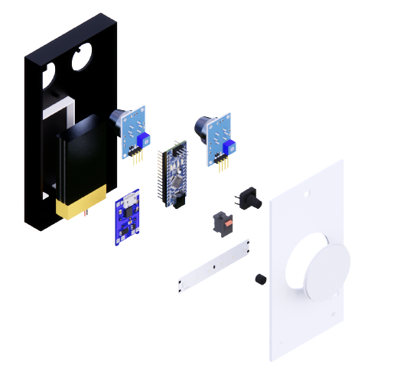

The Food Spoilage Device consists of an Arduino Nano Microcontroller board, MQ-135 and MQ-137 gas sensors, a lithium-ion battery, a battery charger module, an LM5277 module booster voltage, an SPST miniature rocker switch, tactile push buttons, a light-emitting diode, an RGB led, a piezo buzzer, 5.1 k ohms of resistance, and a USB-C serial port. After being soldered and programmed together, the components were encased in a durable plastic container, as shown in Figure 22.

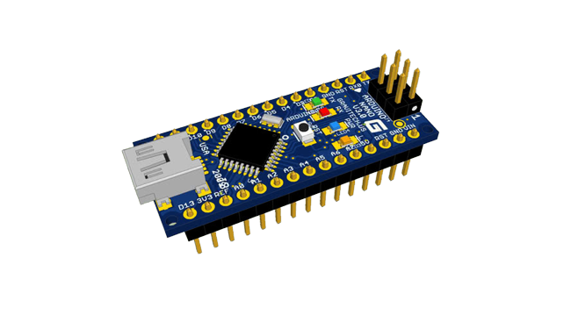

*Figure 23* Arduino Nano Microcontroller Board

The Arduino Nano manages all of the components connected to its board. It also has an Integrated Development Environment (IDE), which is software that allows the program to be created on a computer before being written and transferred to the physical board.

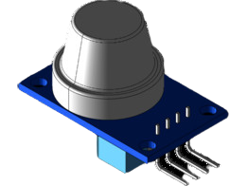

*Figure 24*. MQ-135 Gas sensor for Air Quality

The MQ135 sensor is a low-cost semiconductor that can identify smoke, mono-nitrogen oxides, ammonia, alcohol, carbon dioxide, and benzene. It has a broad range of sensitivity to hazardous gasses. As the concentration of the detecting gas rises, so does its conductivity. This module has both digital and analog outputs.

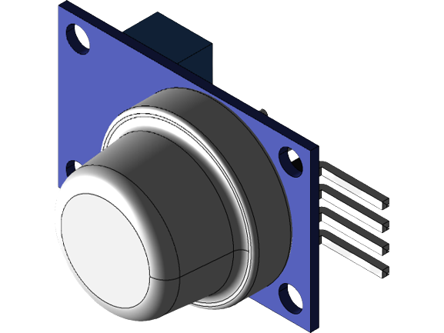

*Figure 25*. MQ-137 Ammonia Detection Sensor

The MQ-137 is an Ammonia (NH3) gas sensor with a SnO2(Tin Oxide) detecting element that has decreased conductivity in clean air. When NH3 (Ammonia) gas is present, the sensor's conductivity increases in proportion to the gas concentration.

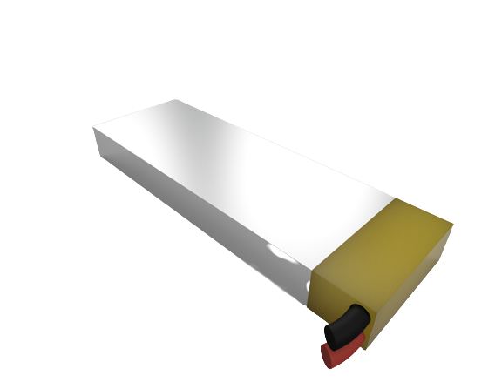

*Figure 26.*  Lithium Ion Polymer 3.7V Battery

The device's power is supplied by a Lithium-Ion battery. The battery is thin, light, and powerful, with a capacity of 3.7v and a capacity of 1200mAh, and an output voltage that ranges from 4.2V when fully charged to 3.7V.

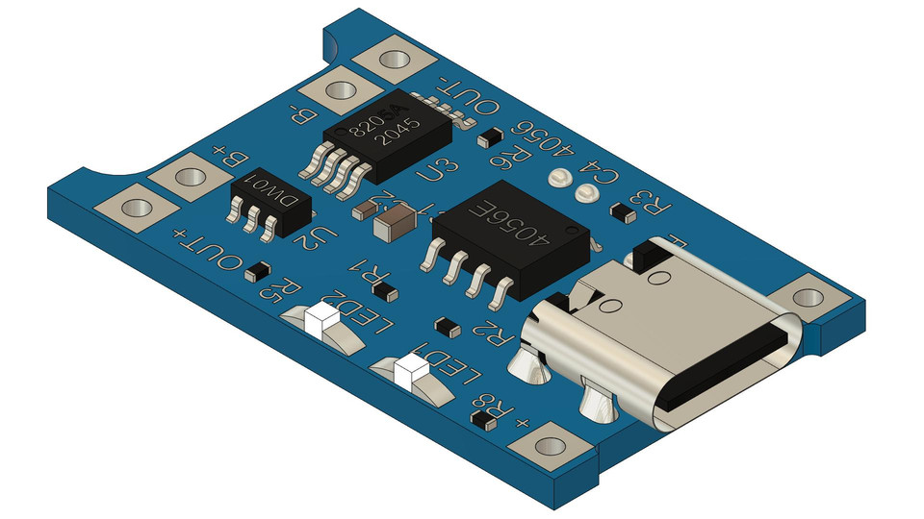

*Figure 27*. TP4056 Lithium Battery Charger Module - Type C

This module is designed to charge rechargeable lithium batteries. In addition to properly charging a lithium battery, the module provides the necessary lithium battery protection.

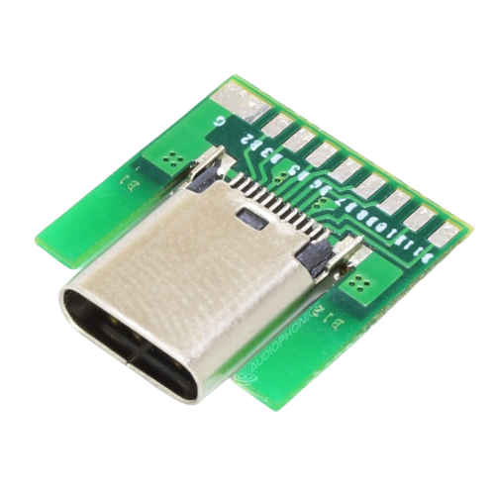

*Figure 28.* DIP Adapter Female Connector - Type C Socket

It transports data and power through a connecting cable which also has the same ports of the connected device.

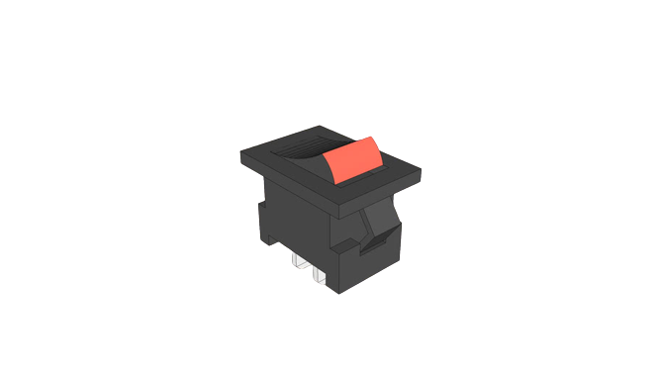

*Figure 29*. SPST Miniature rocker switch

An SPST miniature rocker switch has two terminals that act as electrical connection points and provides simple "ON/OFF" control of the device. To establish a connection between the two terminals, turn the switch "ON" to power up the device.

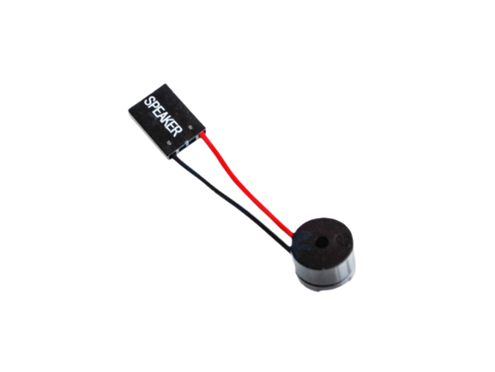

*Figure 30.*  Mini Buzzer With Dupont Connector

The mini buzzer serves as the device's notification sound for each scanned meat.

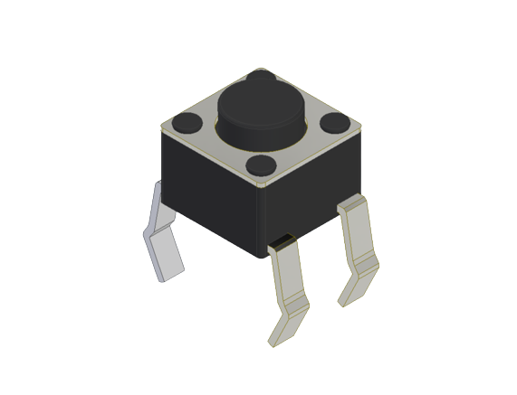

*Figure 31.* Tactile Push Button

The scanned meat is communicated to the device via the tactile push button.

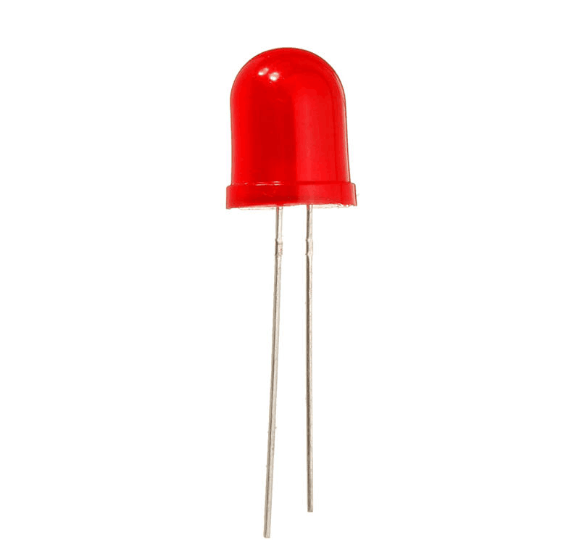

*Figure 32.* Light Emitting Diode

The presence of a Light Emitting Diode indicates that the device is properly turned on.

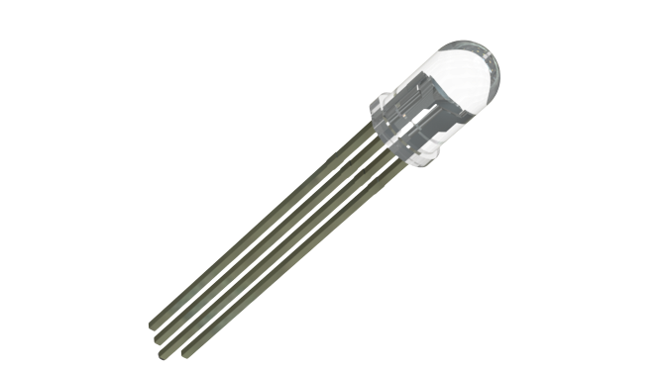

*Figure 33.* RGB

The RGB Led served as a sign that the Food Spoilage Device had assessed the freshness of the meat. It displayed the colors red for spoiled, yellow for not so fresh, green for fresh, and blue to show that the data had been saved in the device.

**

*Figure 34*. Device Data Flow Diagram

Figure 34 showed the flow of the data of the prototype. The ammonia gas from the specimen is detected by the two sensors MQ 135 and MQ 137. The detected gas data then passes to the USB module, whereas it is responsible for sending the data to the android mobile application.

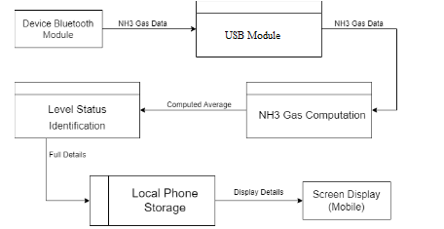

*Figure 35*. Mobile Application Data Flow Diagram

Figure 35 is the continuation of Figure 34 where after the module of the device sends the data, the android mobile application then receives it by USB receiver. The data of Ammonia gas that is collected are then computed to further identify what level of freshness the sample meat belongs to. After identifying the meat’s freshness classification, the data is then stored locally in the application. The data is then displayed on the main screen of the application.

**Operation and Testing Procedure**

This section discusses the testing and operation procedures to assess and evaluate the prototype device comprehensively, the following operations were observed.

The general procedures that must be followed for operating the spoilage detector for cooked and raw meat are the following:

1. Press the power button on the device. The red LED on the device will indicate that this is already turned on.
2. If using along with the companion app, make sure the device is connected via USB to ensure the connection with the mobile application.

The general procedures that must be followed for operating the spoilage detector for testing raw meat are the following:

1. Make sure the sample meat is at room temperature.
2. Slice an opening in the sample meat. If possible, place the sample in a separate container before scanning.
3. Point the device’s area of the sensor to the sample meat and press the scan button.
4. Hold the scan button for a few seconds then release.
5. The meat's freshness is then displayed on the device using RGB LED and if connected to the Android application, it will display the ammonia content that the device detected.

The general procedures that must be followed for operating the spoilage detector for testing cooked meat are the following:

1. Make sure the meat is at room temperature.
2. Slice an opening in the sample meat.
3. If possible, isolate the cooked meat from other ingredients in a dish and place in a separate container before scanning for higher accuracy.
4. Point the device’s area of the sensor to the sample meat and press the scan button.
5. Hold the scan button for a few seconds then release.
6. The meat's freshness is then displayed on the device using RGB LED and if connected to the Android application, it will display the ammonia content that the device detected.

The procedures that must be followed for receiving and analyzing the data for cooked and raw meat on the mobile application are the following:

1. Make sure that the mobile application is installed.
2. Connect the USB from the device to the mobile.
3. Open the Android application.
4. Make sure that the application is connected to the spoilage detector device.
5. Once the device has scanned the data from the sensors, the outputs should show on the mobile application.

This section featured a set of tests to see whether the project met the research objectives in terms of 90% functionality, data accuracy and dependability. The device was evaluated based on general parameters, such as reading the meat sample, evaluating the gasses from the sample, and delivering accurate conclusions based on sample data.

In accordance with the study's aims, the researchers carried out a variety of testing methods, including;

1. Identify the freshness status of raw and cooked meat. The researchers tested the device by analyzing and showing the output on the device or sending the data to the mobile application system when connected.
2. Showing the result through the mobile application. The researchers tested the reliability and accuracy of the analyzed data.

The researchers applied additional testing processes to check the functionality, dependability, and precision of the system.

The following tests were undertaken to confirm the meat spoilage detector's functionality:

1. The system can save and remove the scanned data from the records and show the total number of scanned meat, categorized by freshness.
2. The system can edit the additional information on the scanned data.
3. The system can clear all scanned data from the records.
4. The system can download records into a file to the mobile’s storage.

The following trials that were conducted to ensure the reliability of the food spoilage detector are

1. The device can pair with the mobile application.
2. The standalone device processes the data coming from the sample and shows the correct display corresponding to freshness.
3. The device, when connected to the application, processes the data coming from the sample, and sends it to the application system where it displays the status.

The following trials that were conducted to ensure the accuracy of the food spoilage detector are

1. The system can display the correct status of freshness and ammonia level.
2. The system can save the current time and date along with the said status of freshness and ammonia value.

By applying the aims of the study, the researchers utilized sensors in detecting the spoilage of meat. The researchers also collected data on a real-world context and longitudinal timescale to test the system’s functioning, reliability and accuracy at various points in time.

**Evaluation Procedure**

The respondents of the study were the customers in a selected restaurant, specifically Samgyupsal Restaurant in Bacoor, Cavite. At the restaurant, the customer was the person sitting at the table, and the staff had to provide and meet the service needs of the customer. All customers who entered and dined-in the restaurant were device users. The staff responsible for using the hardware device was also the staff who served the customers' requisition. The instrument for evaluating the unit will be the food spoilage detection device which will be used upon the request of the customer.

The research project was evaluated using the subsequent methods:

1. The researchers will explain to the participants the operational methods, project requirements, and operation of the equipment.
2. The customers will use the device and test its functions. The staff who was in charge of obtaining the customer's order will also be tested on all of its functions.
3. The researcher will explain the Criteria Evaluation Form of Technological University of the Philippines – Cavite Campus and was given to the respondents.
4. The mean of ratings for each criterion was used to gather the average rating per criteria form - Likert Scale-based prototype evaluation form.

**Scale Range and its Qualitative Interpretation**

The researchers gathered the data and proceeded to analyze the ratings after the evaluation. The research project was evaluated using the approved evaluation system instrument for prototype, the Technological University of the Philippines Prototype Criteria Evaluation Form which consisted of the following: functionality based on its performance, aesthetic that focuses on its appearance, workability or availability of materials; durability that was based on the quality of the prototype; and safety that referred to the absence of hazardous and dangerous materials. The gathered data from the TUP Criteria Evaluation Form for prototype were calculated by mean per criteria in the evaluation form: The Descriptive Interpretation of the Mean with a numerical rating of 4.51-5.0 for was Highly Acceptable which was the highest descriptive rating, 3.51-4.0 for Very Acceptable, the Average descriptive rating which was 2.51-3.0 for Acceptable, 1.51- 2.0 which was Fairly Acceptable, and 0.51-1.0 which was Not Acceptable for the lowest descriptive rating were used as the guide for rating. In each criteria the lowest rating was 3.51-4.0 and an overall mean of 4.5 for the prototype to be acceptable. As the researchers gathered all the evaluation forms needed, they proceeded in finalization of results.

Table 1 showed the Likert scale which was used as a measurement tool for evaluating the prototype. The highest rating was 5.0 that corresponded to *Highly Acceptable*, the average rating that corresponded to *Acceptable* was 3.0 and the lowest was 1.0 corresponded to *Not Acceptable.*

Table 1

Likert Scale

**Chapter 4**

**RESULTS AND DISCUSSION**

This chapter contained the Project Description, Project Structure, Project Capabilities and Limitations and Project Test Results.

**Project Description**

The Development Of Ammonia Level Detector For Identifying Selected Meat is a compact device with a companion application that improves service between a restaurant and the consumer. The device informs the customer about the quality of the meat they are about to consume.

The device can be used in one of two ways: standalone or in conjunction with a mobile application. Three colors are used by the standalone device to indicate the quality of the meat: green for fresh, yellow for not so fresh, and red for spoiled raw and cooked meat. A button for scanning and a switch for turning on the standalone device are both included. Only after each beep sound from the device and a light indication on the center top of the device can you identify the difference between fresh, not so fresh, and spoiled meat. The mobile app companion connected to the device has the same functionality as the standalone version, but this time, the user can see all the data.

The data collected by the standalone device will be shown on the mobile app. The mobile application is divided into three sections: the home page, the history page, and the edit page. On the first page, you will find a brief description of how the application will operate. Following the instructions, the status will appear on the screen based on the data read from the device. It also displays the ammonia count of the meat that causes rotting as well as its voltage to identify the meat's state. The history page will save every transaction of the day. The total number of fresh, not so fresh, and spoiled meat is shown here. Additionally, the location, status, values, and user comments of the transaction are all visible here, as well as the date and time of the purchase. There will also be an edit and delete button of each line of the data. Inside also of this page has a button for downloading the data to the cellphone or a button for clearing all the history data. The import button will be used only if the standalone device is used on another mobile device. By this, it will show all the gathered data on both mobile devices without losing it. Figure 36 shows the prototype of the Meat Spoilage Detector device using Arduino Nano microcontroller.

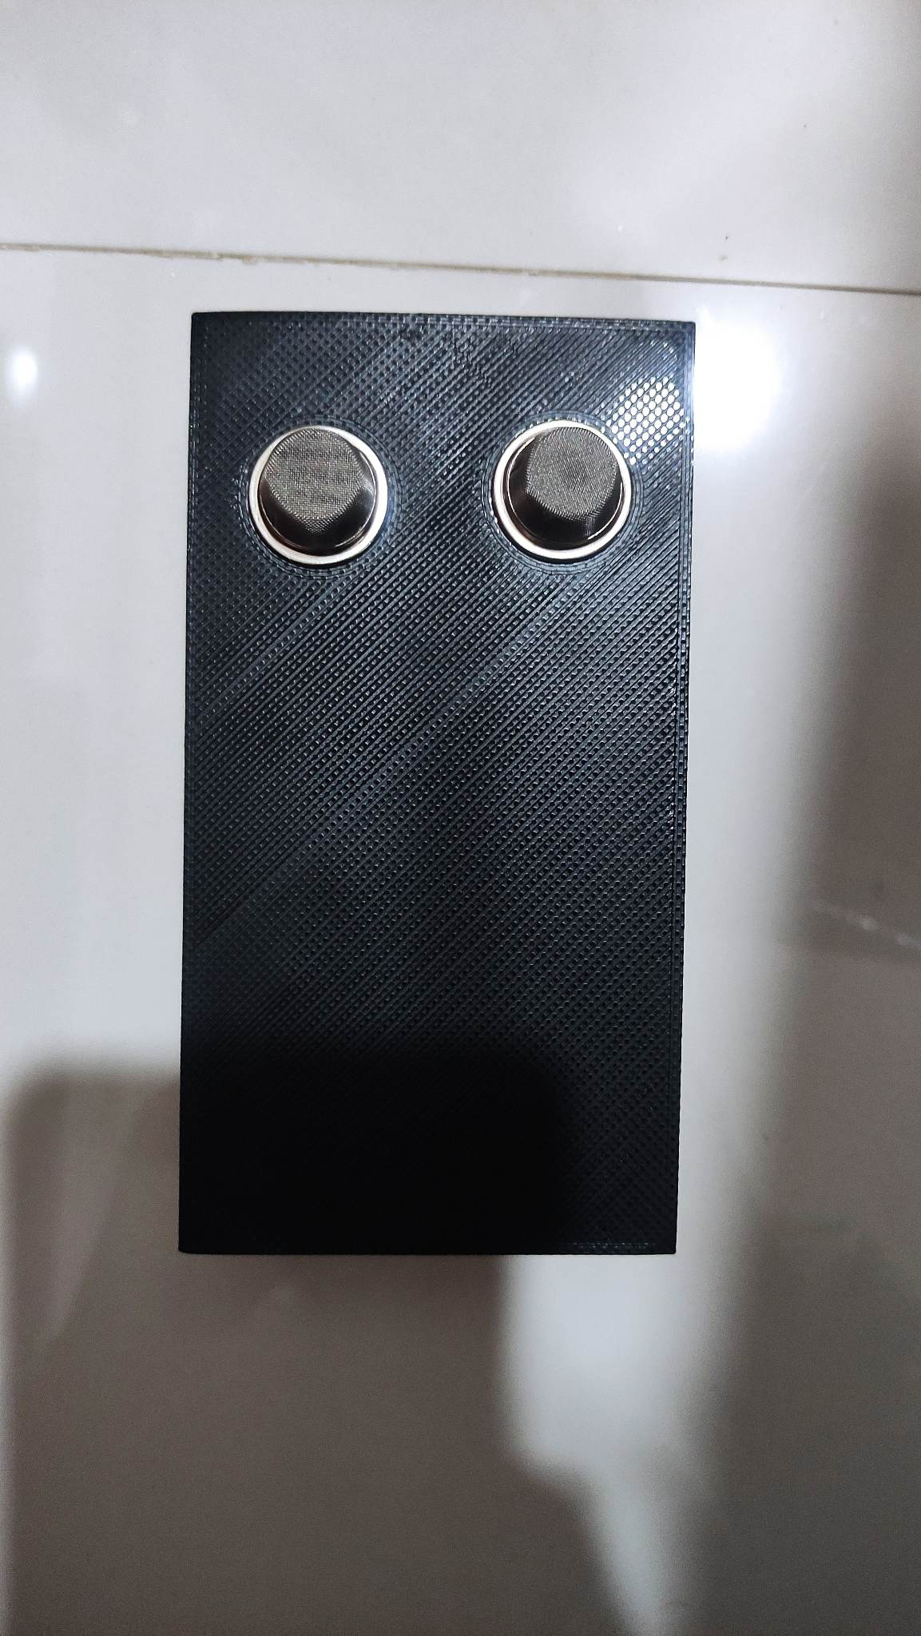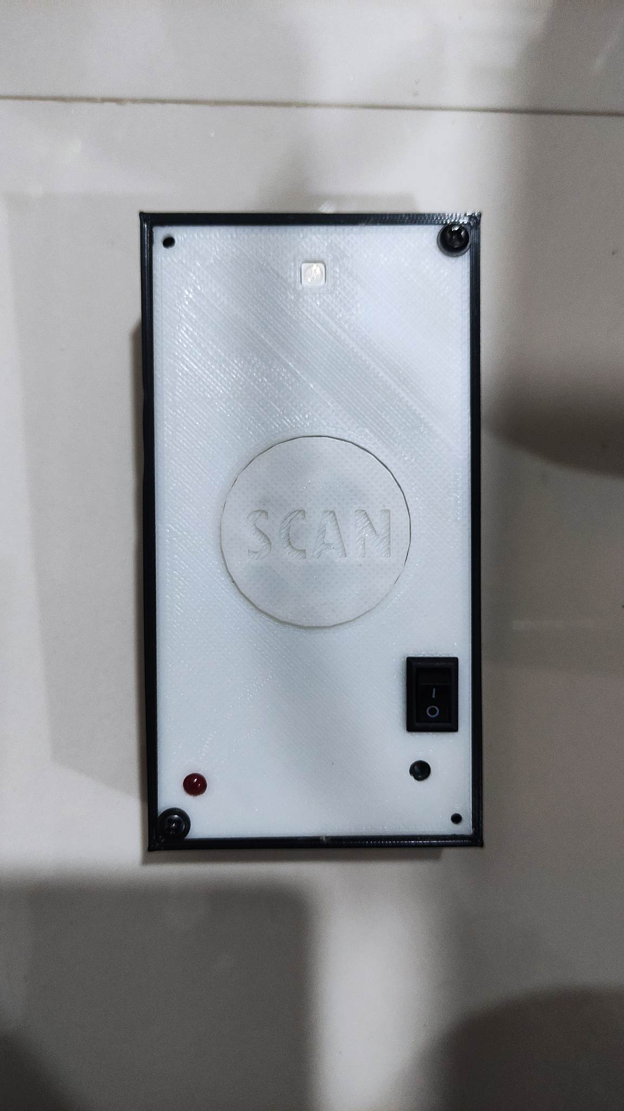

*Figure 36.* Prototype of the Meat Spoilage Detector Device

**Project Structure**

Figure 37 shows the inside view of the unfinished device. The case is made up of High Impact Polystyrene or HIPS - plastic filament used for dissolvable support structures in 3D printers encasing the components intact and secured. The only way to open the case was to unscrew the screws and lift up the cover that was covering the device. The MQ sensor is located at the back of the device exposing the sensing element of the sensor to easily detect the ammonia of the meat. Whenever the Meat Spoilage Detector Device battery is low, TP4056 Lithium Battery Charger Module - Type C socket was placed just beneath the Tactile Button in order to easily charge it. The Meat Spoilage Detector Device Dimension was 5.07 inches in height and 1.02 inches width of the back case while the cover measures 2.06 inches in length and 0.3 inches width. The fittings for the Tactile Push Buttons were 0.2 in diameter and 0.1 diameter for Light Emitting Diode.

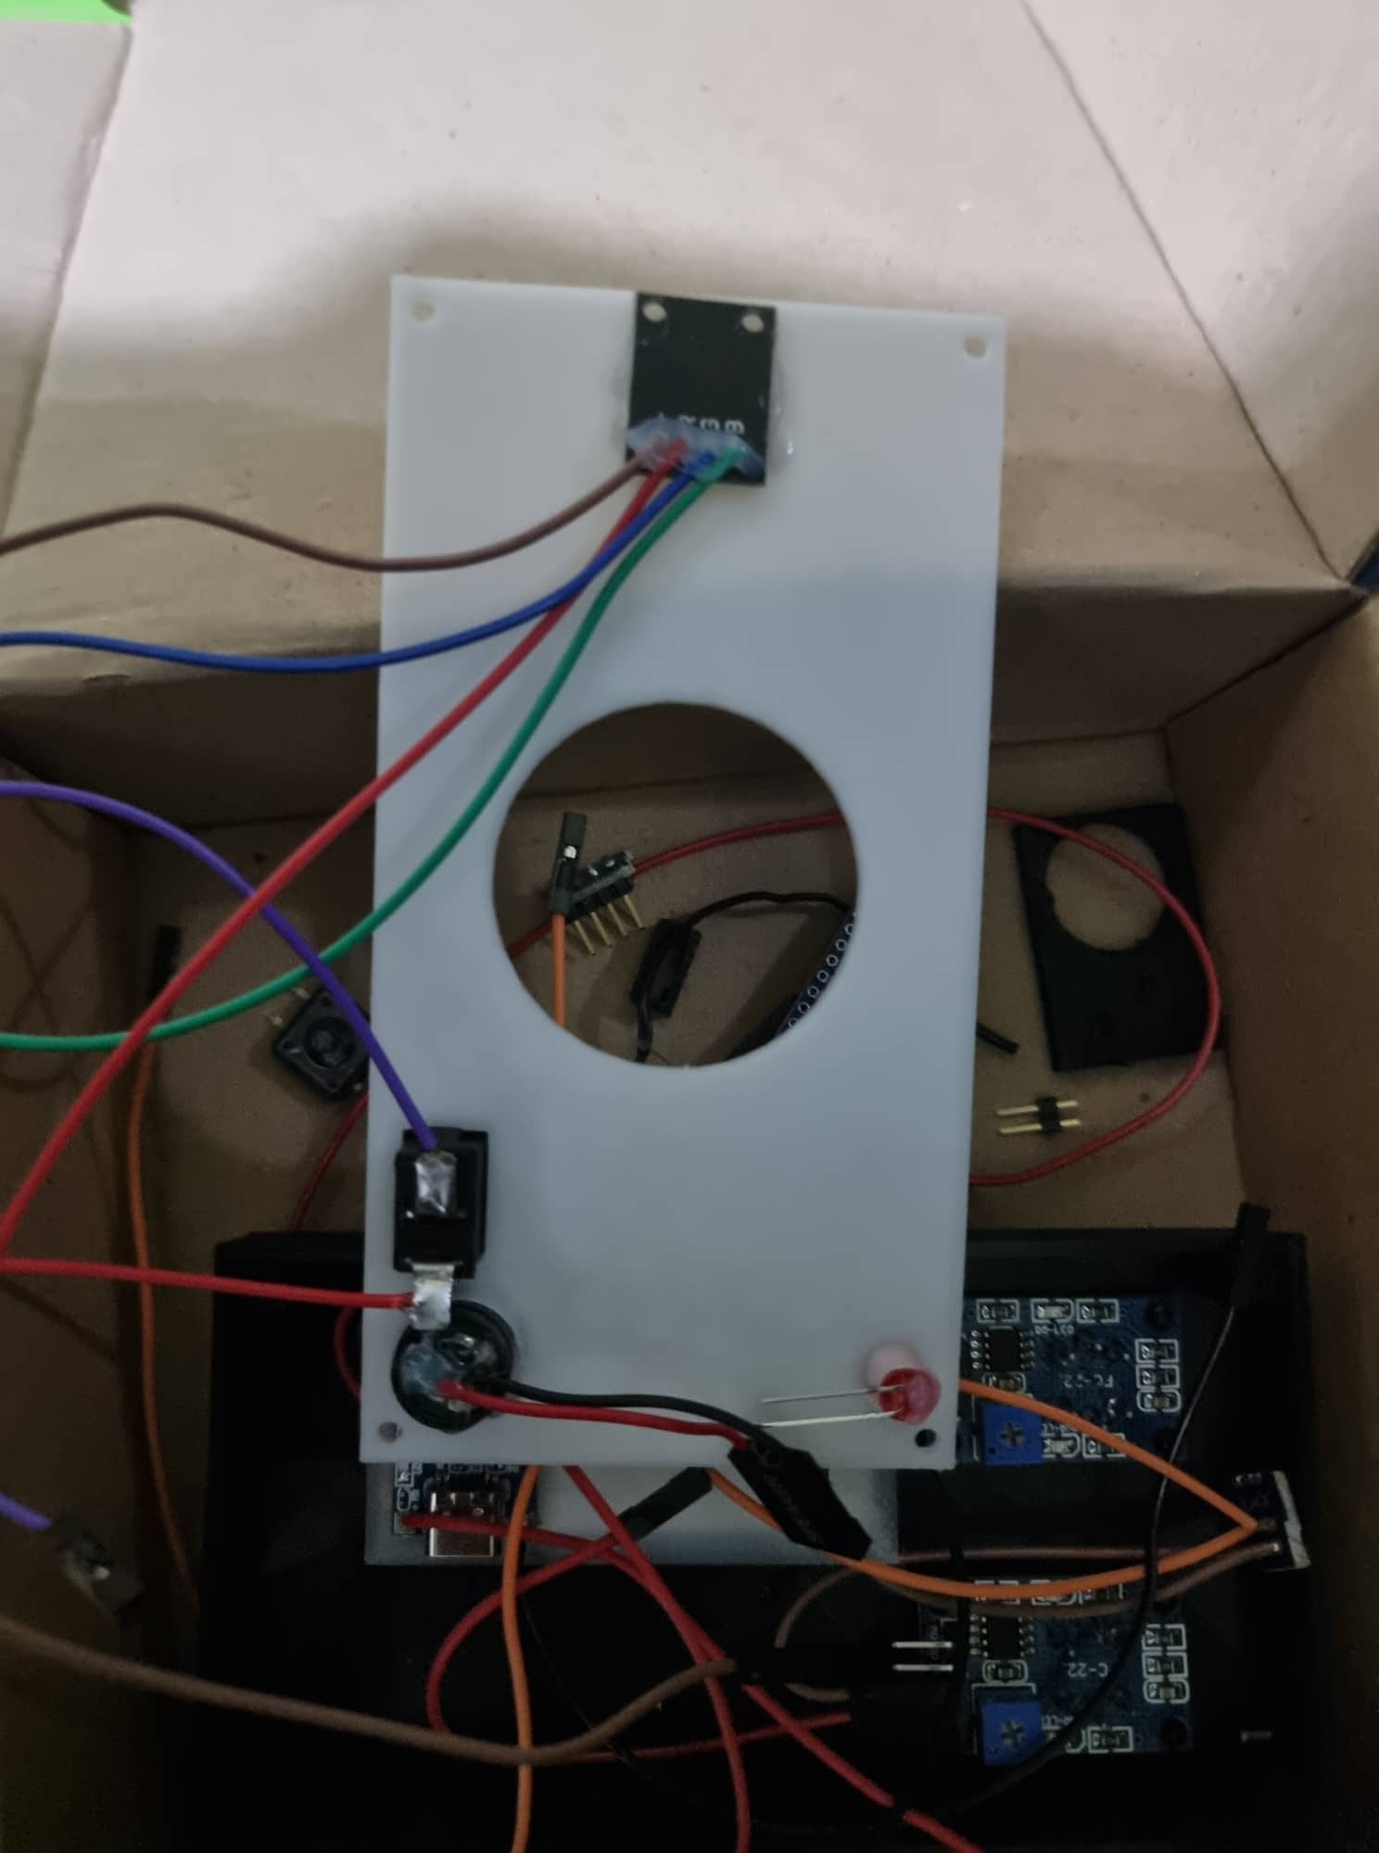

*Figure 37.* Unfinished Meat Spoilage Detector Device

Figure 38 showed the connection between the components. The main power source is a 3.7 V Lithium Ion Polymer Battery, enclosed in a battery holder inside to ensure the safety of the battery. . The battery is connected to TP4056, a charging and protection board. This particular device is protecting the battery from over and under voltage when the device needs to be charged to extend the battery's life. The TP4056 is still outputting the battery's raw voltage that ranged from 4.2 V to 2.8 V so it needs to be regulated to 5V Arduino Nano. From the main component, there are some components that are connected to its pins, the MQ 135 is connected to AO, ground and VCC, while the MQ137 sensor is connected to pin A1 to avoid confusion on MQ135. The tactile push button that is connected to pin D5, followed by the RGB LED that is connected at pin D4, and the buzzer at D9 pin.

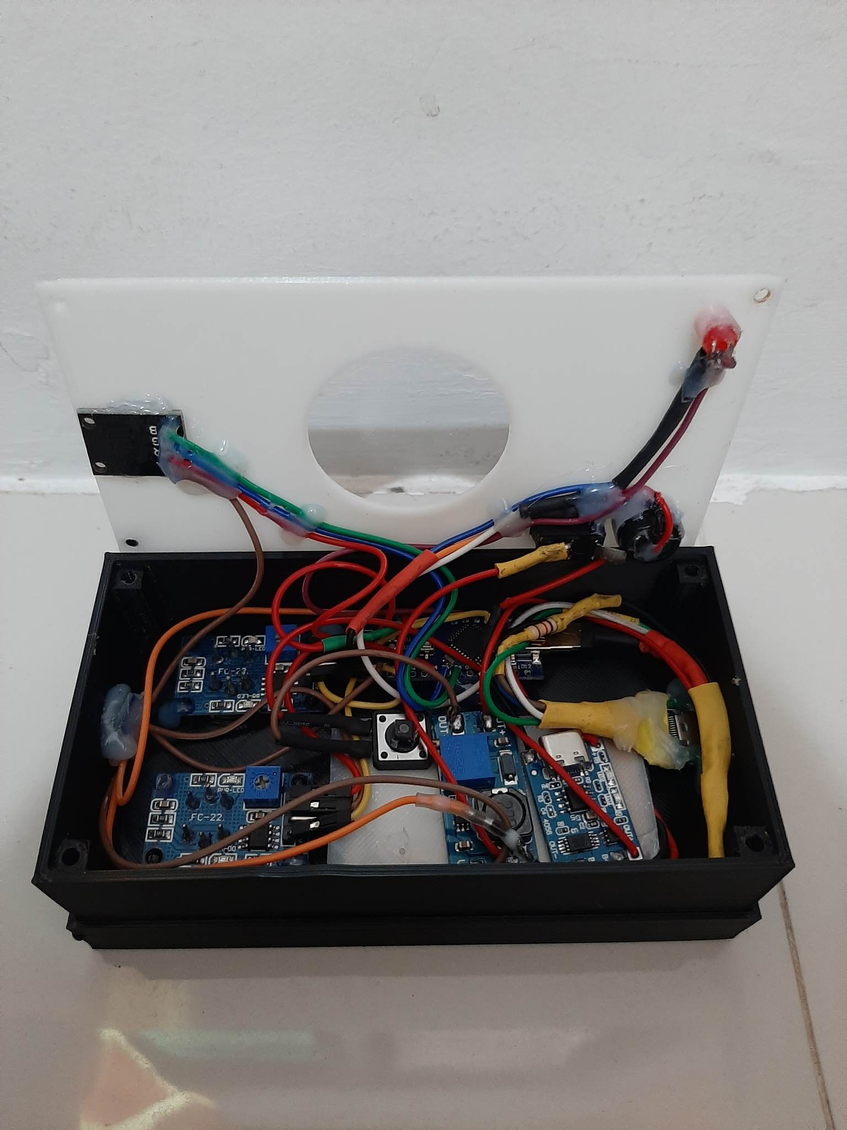

*Figure 38.* Meat Spoilage Detector Device Components

|  |  |
| --- | --- |

*Figure 39*. Starting Page | *Figure 40.*  Connecting Device Page

Figure 39 shows the home page of the mobile application. This part has the app logo and a “Begin” button to go to the next page shown in Figure 40. This section has a refresh button to scan for connected devices and a navigation bar on the top right showing the records or history and baud rate. When the mobile phone is connected to the device, it will be displayed on the screen.

|  |  |  |
| --- | --- | --- |

*Figure 41 .* Mobile Phone Devices Available | *Figure 42*. Brief Instruction

Figure 41 indicates the available devices connected to the mobile application and Figure 42 shows the brief description of how to use the mobile app connected to the device. In this page, you can also view or click the “view records” button to show the history of the transaction made on the stand alone device.

|  |  |  |
| --- | --- | --- |

*Figure 43*. Fresh Status | *Figure 44.* Not so Fresh Status | *Figure 45.* Spoiled Status

The three figures shown above show the status of each meat. It has the logo of each status, the ammonia count by ppm measures and millivolt . Each page also has a “View Records” button to easily view the history records. In here, there are two sub-category of the not so fresh status, one is for safe consumption and the other is unsafe for consumption, this is for the user to easily know if it’s safe even if it’s not so fresh and do some alternative methods.

|  |  |
| --- | --- |

*Figure 46.* History Page | *Figure 47.* Edit Page

Figure 46 shows the history page. Here, you will see all the transactions made from date and time, the status, the value gathered from the device, the purchase location and comments. You will also see two buttons for editing the specific data or delete it. You will also see a button for importing data and downloading data. And a clear all button for deleting all the data in the history page.

**Project Test Results**

This section contains the results of the tests conducted for the functionality,

reliability and accuracy of the project.

**Testing Results for Functionality**

Table 2 shows the testing results for the meat spoilage detector in adding and deleting a scanned data in the records of the system. The total count displays the number of scanned data categorized by freshness.

**Table 2**

*Testing Results for Adding and Deleting Scanned Data*

| **Trial** | **Classification** | **Action** | **Total Count** |
| --- | --- | --- | --- |
| 1 | Fresh | Add | **Fresh**- 1 ;  **Not so Fresh -** 0 ; **Spoiled** - 0 |
| 2 | Not so Fresh | Add | **Fresh**- 1 ;  **Not so Fresh -** 1 ; **Spoiled** - 0 |
| 3 | Spoiled | Add | **Fresh**- 1 ;  **Not so Fresh -** 1 ; **Spoiled** - 1 |
| 4 | Fresh | Remove | **Fresh**- 0 ;  **Not so Fresh -** 1 ; **Spoiled** - 1 |
| 5 | Not so Fresh | Remove | **Fresh**- 0 ;  **Not so Fresh -** 0 ; **Spoiled** - 1 |
| 6 | Spoiled | Remove | **Fresh**- 0 ;  **Not so Fresh -** 0 ; **Spoiled** - 0 |

Table 3 shows the testing results for editing the scanned data gathered on the device. The additional information can be edited or removed if needed.

**Table 3**

*Testing Results for Editing of Scanned data information*

| **Trial** | **Data** | **Action** | **Purchase location information Status** | **Comment Status** |
| --- | --- | --- | --- | --- |
| 1 | **Purchase location** | Edit | Updated | No data |
| 2 | **Comment** | Edit | Sustained | Updated |
| 3 | **Purchase location and Comment** | Edit | Updated | Updated |
| 4 | **Purchase location** | Remove | No data | Sustained |
| 5 | **Comment** | Remove | No data | No data |
| 6 | **Purchase location and Comment** | Remove | No data | No data |

Table 4 shows the testing results for exporting the record of scanned data through csv file. The downloaded file can be found in the local storage of the mobile and shared through the user’s preferred method.

**Table 4**

*Testing Results for downloading records as CSV file*

| **Trial** | **Download record of scanned data** |
| --- | --- |
| 1 | Success |
| 2 | Success |
| 3 | Success |

Table 5 shows the testing results for clearing all data from records. Users can choose to clear all records gathered from scanning the data and this will delete all the history available and reset the counter for total sample scanned categorized by freshness.

**Table 5**

*Testing Results for Clearing all records*

| **Trial** | **Clear all data from records** |
| --- | --- |
| 1 | Success |
| 2 | Success |
| 3 | Success |

**Testing Results for Reliability**

Table 6 shows the testing results for the pairing device to mobile application using USB-C Cable. The device is paired in the mobile application in order to send data to its destination.

**Table 6**

*Testing Results for Pairing Device to Mobile Application Using USB-C Cable*

| **Trial** | **Device** | **Mobile Application** | **Status** |
| --- | --- | --- | --- |
| 1 | Connected | Connected | Paired |
| 2 | Connected | Not Connected | Not Paired |
| 3 | Not Connected | Connected | Not Paired |
| 4 | Not Connected | Not Connected | Not Paired |

Table 7 shows the testing results for the standalone device. Here, the RGB indicator and each classification's state are displayed together with the range for each category.

**Table 7**

*Testing Results for Standalone Device*

| **Trial** | **Classification** | **RGB Indicator** | **Status** |
| --- | --- | --- | --- |
| **1** | **Fresh** (<= 559 mV) | Green | Match |
| **2** | **Not so Fresh**  (560 - 719 mV)  *safe for consumption* | Yellow | Match |
| **3** | **Not so Fresh** (720- 729 mV)  *unsafe for consumption* | Yellow | Match |
| **4** | **Spoiled**  (>= 730 mV) | Red | Match |

Table 8 shows the testing results for the connected device and mobile application. The RGB indicator of the device and the color of Mobile Application shows the matching color of each classification.

**Table 8**

*Testing Results for Connected Device and Mobile Application*

| **Trial** | **Classification** | **Mobile Application** | **RGB Indicator** | **Status** |
| --- | --- | --- | --- | --- |
| **1** | **Fresh** (<= 559 mV) | Green | Green | Match |
| **2** | **Not so Fresh**  (560 - 719 mV)  *safe for consumption* | Yellow | Yellow | Match |
| **3** | **Not so Fresh** (720- 729 mV)  *unsafe for consumption* | Yellow | Yellow | Match |
| **4** | **Spoiled**  (>= 730 mV) | Red | Red | Match |

**Testing Results for Accuracy**

Table 9 shows the testing results for the Ammonia Test Drop and the Meat Spoilage Detector Device for Cooked meat. The two were put through their paces at the same time.

**Table 9**

*Testing Results for Ammonia Test Drop and Device for Cooked Meat Table*

| **Trial** | **Sample** | **Ammonia Test Drop**  **Range (mg)** | **Device Range**  **(mV)** | **Outcome Value**  **(Ammonia)** | **Outcome Value**  **(Device)** | **Result** |
| --- | --- | --- | --- | --- | --- | --- |
| **1** | Beef | Fresh  ( 0 - < 0.2) | Fresh  (<= 559) | 0.1 mg | 484 mV | Match |
| **2** | Beef | Not so Fresh  (>= 0.2 < 0.4) | Not so Fresh  (560 -729) | 0.2 mg | 622 mV | Match |
| **3** | Beef | Spoiled  (> 0.4) | Spoiled  (>= 730) | 0.4 mg | 814 mV | Match |
| **4** | Chicken | Fresh  ( 0 - < 0.2) | Fresh  (<= 559) | 0.1 mg | 512 mV | Match |
| **5** | Chicken | Not so Fresh  (>= 0.2 < 0.4) | Not so Fresh  (560 -729) | 0.2 mg | 650 mV | Match |
| **6** | Chicken | Spoiled  (> 0.4) | Spoiled  (>= 730) | 0.4 mg | 916 mV | Match |
| **7** | Pork | Fresh  ( 0 - < 0.2) | Fresh  (<= 559) | 0.1 mg | 526 mV | Match |
| **8** | Pork | Not so Fresh  (>= 0.2 < 0.4) | Not so Fresh  (560 -729) | 0.2 mg | 606 mV | Match |
| **9** | Pork | Spoiled  (> 0.4) | Spoiled  (>= 730) | 0.4 mg | 824 mV | Match |

Table 10 shows the testing results for the Ammonia Test Drop and the Meat Spoilage Detector Device for Raw meat. The two were put through their paces at the same time.

**Table 10**

*Testing Results for Ammonia Test Drop and Device for Raw Meat Table*

| **Trial** | **Sample** | **Ammonia Test Drop**  **Range (mg)** | **Device Range**  **(mV)** | **Outcome Value**  **(Ammonia)** | **Outcome Value**  **(Device)** | **Result** |
| --- | --- | --- | --- | --- | --- | --- |
| **1** | Beef | Fresh  ( 0 - < 0.2) | Fresh  (<= 559) | 0.1 mg | 510 mV | Match |
| **2** | Beef | Not so Fresh  (>= 0.2 < 0.4) | Not so Fresh  (560 -729) | 0.2 mg | 694 mV | Match |
| **3** | Beef | Spoiled  (> 0.4) | Spoiled  (>= 730) | 0.4 mg | 846 mV | Match |
| **4** | Chicken | Fresh  ( 0 - < 0.2) | Fresh  (<= 559) | 0.1 mg | 504 mV | Match |
| **5** | Chicken | Not so Fresh  (>= 0.2 < 0.4) | Not so Fresh  (560 -729) | 0.2 mg | 682 mV | Match |
| **6** | Chicken | Spoiled  (> 0.4) | Spoiled  (>= 730) | 0.4 mg | 870 mV | Match |
| **7** | Pork | Fresh  ( 0 - < 0.2) | Fresh  (<= 559) | 0.1 mg | 506 mV | Match |
| **8** | Pork | Not so Fresh  (>= 0.2 < 0.4) | Not so Fresh  (560 -729) | 0.2 mg | 682 mV | Match |
| **9** | Pork | Spoiled  (> 0.4) | Spoiled  (>= 730) | 0.4 mg | 958 mV | Match |

Table 11 shows the testing results for saving the exact time and date the sample was scanned. The time and the current date is saved along with the freshness status of the sample and the corresponding ammonia value.

**Table 11**

*Testing Results for Scanned Sample Time and Date*

| **Trial** | **Current Time** | **Saved Time** | **Current Date** | **Saved Date** |
| --- | --- | --- | --- | --- |
| 1 | 14:51:33 | 14:51:33 | 11/08/2022 | 11/08/2022 |
| 2 | 16:11:38 | 16:11:38 | 11/08/2022 | 11/08/2022 |
| 3 | 15:07:12 | 15:07:12 | 11/09/2022 | 11/09/2022 |
| 4 | 17:40:13 | 17:40:13 | 11/09/2022 | 11/09/2022 |
| 5 | 16:37:48 | 16:37:48 | 11/25/2022 | 11/25/2022 |
| 6 | 17:42:39 | 17:42:39 | 11/25/2022 | 11/25/2022 |

**Project Capabilities and Limitations**

The development of an Ammonia Level Detector for identifying selected meat utilizes sensors to help with determining the freshness level of meat in a diner. The device scans and can show or send the status to the mobile application. The companion application receives the data from the device and displays the freshness status of the sample meat.

The following were the capabilities of the developed prototype:

1. Scan sample using standalone device.

2. Display the freshness level status of the sample using a light indicator when standalone and through the application when connected to mobile.

3. Save the total number of samples scanned based on freshness level in the mobile application.

5. Users can view the history of the scanned samples.

6. Users can add additional information on the scanned data in the mobile application.

7. Users can export data to a file on the application and transfer to another mobile using their preferred method.

However, the following were the limitations of the developed prototype.

1. The Ammonia Level Detector Device for identifying selected meat can only send data using the local network.

2. The accuracy of the detected value of the device depends on the distance between the device sensor and sample, and the amount of time the scan button was pressed.

3. The device can only be connected to the mobile application using Type C to C cable.

4. The scanned data will only be recorded when the device is connected to the mobile application.

**Chapter 5**

**SUMMARY OF FINDINGS, CONCLUSION AND RECOMMENDATIONS**

This chapter presents the summary of the findings, conclusions and recommendations focusing on the data discussed in the previous chapter. This chapter summarizes the study's findings without providing a great deal of in-depth information. The conclusion contains generalizations and other interferences, while this chapter also contains the researchers' recommendations for the study's beneficiaries.

**Summary of Findings**

The primary goal of this research was to create a mobile application and gadget equipped with an ammonia gas sensor that can determine the freshness of beef, pork, and chicken in both their raw and cooked forms. We employed MQ-137 and MQ-135 sensors to detect ammonia gas (NH3) and other gaseous compounds that help classify the meat's freshness. For this research, an ammonia liquid tester was used to analyze meat samples. The test findings showed that the device, either alone or in conjunction with a mobile app, accurately detected ammonia gas levels that indicate whether the meat was fresh, not so fresh, or rotten. Multiple problems were encountered during the course of the study, including the disconnection of a type-c cable, the slow performance of the mobile app, and the difficulty in assessing rotting meat samples because of the unpleasant smell and poisonous gasses they gave off.

**Conclusions**

In this paper, we proposed a device for selected meat freshness detection based on the ammonia level. Through gas sensors, we successfully obtained the relationship between meat freshness and gasses released. We based our ammonia level chart from an existing study as a standard for our judgment. Through comparisons with the existing chart, the data obtained from the sensors was divided into 3 categories: Fresh, Not so Fresh, and Spoiled. In order to confirm the usefulness of the proposed device, we performed experiments on raw and cooked beef, pork and chicken meat. Unfortunately, the existing device as to be one of the parameters was already not available to the market thus the only parameter we had was the ammonia drop test.

The following conclusions are drawn from the study's findings:

1. The researchers successfully designed and developed a device that can identify the level of freshness of raw and cooked beef, pork and chicken meat.
2. The researchers determined the total number of meat quality scanned - fresh, not so fresh, and spoiled.
3. The researchers successfully showed the records of meat scan date/time and purchase information.
4. The researchers evaluated the food spoilage detector and achieved atleast 90% functionality, accuracy, and reliability.

**Recommendations**

The researchers offers the following recommendations for future researchers who will further improve the state of the said prototype entitled, “DEVELOPMENT OF AMMONIA LEVEL DETECTOR FOR IDENTIFYING SELECTED MEAT”

1. Wireless data transmission from the physical prototype to the mobile application.

2. To consider replacing the buzzer with a text-to-speech module to dictate the freshness category when scanned.

3. A more compact and integrated design for the Ammonia Level Detector.

4. To include a percentage indicator in order to determine the battery life.

5. Fit the gas sensors inside the device without decreasing the accuracy of detection in order to protect the sensors from being drenched or exposed to the test subject.

6. More features on the system, such as the ability to save the records with only the standalone device, and to import existing file available without duplicating the records.

**REFERENCES**

* 17+ statistics about meat consumption. ChefsTemp. (2022, May 11). Retrieved December 17, 2022, from https://www.chefstemp.com/statistics-about-meat-consumption/
* Agarwal, T. (2022, July 18). MQ135 Alcohol Sensor Circuit and Its Working. ElProCus - Electronic Projects for Engineering Students. https://www.elprocus.com/mq-135-alcohol-sensor-circuit-and-working/
* Andersen, C. H. (2022, November 22). How Long Does Cooked Meat Last in the Fridge? Reader’s Digest. https://www.rd.com/list/meat-storage-guidelines/
* Android | operating system | Britannica. (2020). In Encyclopædia Britannica. Retrieved from https://www.britannica.com/technology/Android-operating-system
* Case, C. (2021, April 8). A Guide for Beef Enthusiast: How to Check Meat’s Freshness. InstaBulletin. https://www.instabulletin.com/a-guide-for-beef-enthusiast-how-to-check-meats-freshness/
* Cohen, S. (2022, November 27). Foods High in Ammonia: to Eat or Not to Eat. Blend of Bites. https://blendofbites.com/foods-high-in-ammonia/
* Corusadmin. (2022, February 10). Best refrigerator rules: How long do leftovers last? Recipes, news, tips and how-tos. Food Network Canada. Retrieved December 17, 2022, from https://www.foodnetwork.ca/article/refrigerator-rules-how-long-do-leftovers-last/
* Davidson, K. M. (2021, April 23). How to Tell if Chicken Has Gone Bad. Healthline. https://www.healthline.com/nutrition/how-to-tell-if-chicken-is-bad
* Dena, A. A. S. (2021, October 28). User-friendly lab-on-paper optical sensor for the rapid detection of bacterial spoilage in packaged meat products. RSC Advances (RSC Publishing). https://pubs.rsc.org/en/content/articlelanding/2021/RA/D1RA06321A
* Emmanuel, Z. M. J. (2018, July 9). Caractérisation des mécanismes d’altération des produits camés et de la mer par Brochothrix thermosphacta. http://www.theses.fr/. https://www.theses.fr/2018NANT4020
* Foodborne Illness - MN Dept. of Health. (n.d.). https://www.health.state.mn.us/diseases/foodborne
* Ghasemi-Varnamkhasti, M. (n.d.). Meat Quality Assessment by Electronic Nose (Machine Olfaction Technology). MDPI. https://www.mdpi.com/1424-8220/9/8/6058
* Hanwei Electronics Co.,ltd MQ-136 http://www.hwsensor ... - sensorica.ru. Technical Data of MQ-136 Gas Sensor . (n.d.). Retrieved June 7, 2022, from http://www.sensorica.ru/pdf/MQ-136.pdf
* Hummel, C. (n.d.). What Causes Meat to Spoil? LEAFtv. Retrieved June 14, 2022, from https://www.leaf.tv/articles/what-causes-meat-to-spoil/
* Kumar, M. (2018). Issue 3 www.jetir.org (ISSN-2349-5162). JETIREP06022 Journal of Emerging Technologies and Innovative Research, 5. https://www.jetir.org/papers/JETIREP06022.pdf
* Laferte, M. (2022, December 1). How to tell if Cooked Meat is Bad – All You Need to Know. Your Cutlery Advisor. https://cutleryadvisor.com/how-to-tell-if-cooked-meat-is-bad/
* Last Minute Engineers. (2018, August 14). How MQ2 Gas/Smoke Sensor Works? & Interface it with Arduino. Last Minute Engineers; Last Minute Engineers. https://lastminuteengineers.com/mq2-gas-senser-arduino-tutorial/
* Magar, S. T. (2021, April 22). Microbial spoilage of meat and meat products. Microbe Notes. https://microbenotes.com/microbial-spoilage-of-meat-and-meat-products/
* Matindoust, S., Farzi, G., Nejad, M. B., & Shahrokhabadi, M. H. (2021). Polymer-based gas sensors to detect meat spoilage: A review. Reactive and Functional Polymers, 165, 104962. https://doi.org/10.1016/j.reactfunctpolym.2021.104962
* Melissa. (2015, March 30). Why chicken goes bad so quickly. Today I Found Out. Retrieved June 7, 2022, from http://www.todayifoundout.com/index.php/2015/03/chicken-goes-bad-quickly/
* MQ-9 Semiconductor Sensor for CO/Combustible Gas. (n.d.). http://www.haoyuelectronics.com/Attachment/MQ-9/MQ9.pdf
* MQ135 Alcohol Sensor Circuit and Its Working. (2016, May 4). ElProCus - Electronic Projects for Engineering Students. https://www.elprocus.com/mq-135-alcohol-sensor-circuit-and-working/
* Paretts, S. (2019, January 10). Indications of Refrigerated Cooked Meat Spoiled. Our Everyday Life. https://oureverydaylife.com/indications-refrigerated-cooked-meat-spoiled-42201.html
* Patricia, M., Azanza, V., Niño, B., Membrebe, Q., Grace, R., Sanchez, R., Estilo, E., Grace, U., Dollete, M., Feliciano, R., Kristel, N., & Garcia, A. (2019). Foodborne Disease Outbreaks in the Philippines (2005-2018).
* Philippine Journal of Science, 148(2), 317–336. <https://philjournalsci.dost.gov.ph/images/pdf/pjs_pdf/vol148no2/foodborne_disease_outbreaks_in_the_Philippines_.pdf>
* Rustia, A. S. (2021, April 16). Defining Risk in Food Safety in the Philippines. http://www.foodandnutritionjournal.org/volume9number1/defining-risk-in-food-safety-in-the-philippines/
* Shahzad, N., Khalid, U., & Iqbal, A. (2018). eFresh -a Device to Detect Food Freshness. International Journal of Soft Computing and Engineering (IJSCE), 3,2231–2307. https://www.ijsce.org/wp-content/uploads/papers/v8i3/C3146078318.pdf
* Simply Healthy Family - Team. (2022, June 3). How Can You Tell if Pork is Spoiled? 4 Signs of Rotten Pork. Simply Healthy Family. https://www.simplyhealthyfamily.org/how-can-you-tell-if-pork-is-spoiled/
* Statista. (2022, November 15). Per capita meat consumption in the Philippines 2022,by type. https://www.statista.com/statistics/756518/philippines-meat-consumption-per-capita-by-type/
* Techopedia. (2020, August 7). Mobile Application (Mobile App). Techopedia.com. https://www.techopedia.com/definition/2953/mobile-application-mobile-app
* Terry, O. V. (n.d.). A Smart IOT Food Quality Monitoring System. MOI UNIVERSITY -SCHOOL OF ENGINEERING DEPARTMENT OF ELECTRICAL AND COMMUNICATIONS. Retrieved June 7, 2022, from https://www.worldenergyday.net/wp-content/uploads/2021/06/A-Smart-IOT-Food-Quality-Monitoring-System-Terry-Valary.pdf
* The Facts About Ammonia. (n.d.). https://www.health.ny.gov/environmental/emergency/chemical_terrorism/ammonia_general.htm
* The United States Meat Industry at a Glance. (n.d.). https://www.meatinstitute.org/index.php?ht=d/sp/i/47465/pid/47465
* Thienes, C. P., Masiri, J., Benoit, L. A., Barrios-Lopez, B., Samuel, S. A., Cox, D. P., Dobritsa, A. P., Nadala, C., & Samadpour, M. (2018). Quantitative Detection of Pork Contamination in Cooked Meat Products by ELISA. Journal of AOAC INTERNATIONAL, 101(3), 810–816. https://doi.org/10.5740/jaoacint.17-0036
* Tulus Ikhsan Nasution, Rica Asrosa, & Irwana Nainggolan. (2018, December). Application of MQ-138 Semiconductor Sensor for Breath Acetone Detection. ResearchGate; IOP Publishing. https://www.researchgate.net/publication/329890530_Application_of_MQ-138_Semiconductor_Sensor_for_Breath_Acetone_Detection
* Valdez, M., Gupta, S. K., Lozano, K., & Mao, Y. (2019). ForceSpun polydiacetylene nanofibers as colorimetric sensor for food spoilage detection. Sensors and Actuators B: Chemical, 297, 126734. https://doi.org/10.1016/j.snb.2019.126734
* Velcro-like food sensor detects spoilage and contamination. (2020, September 9). MIT News | Massachusetts Institute of Technology. https://news.mit.edu/2020/velcro-food-sensor-spoilage-0909
* Xiong, Z., Sun, D.-W., Zeng, X.-A., & Xie, A. (2014). Recent developments of hyperspectral imaging systems and their applications in detecting quality attributes of red meats: A review. Journal of Food Engineering, 132, 1–13. https://doi.org/10.1016/j.jfoodeng.2014.02.004
* Zhou, B., Ou, W., Zhao, C., Shen, J., Zhang, G., Tang, X., Deng, Z., Zhu, G., Li, Y. Y., & Lu, J. (2021). Insertable and reusable SERS sensors for rapid on-site quality control of fish and meat products. Chemical Engineering Journal, 426, 130733. https://doi.org/10.1016/j.cej.2021.130733
* Zhu, X. (2015). OhioLINK ETD: Zhu, Xiaoyi. https://etd.ohiolink.edu/apexprod/rws_olink/r/1501/10?clear=10&p10_accession_num=osu1437750532